**AWS CLI AND SDK**

**SDK:** for **Node.js, Python, Java(double check)**. Each AWS element is a class.

Default region:

You specify a Region when configuring the SDK for JavaScript so that the SDK accesses the resources in that Region. Some services are available only in specific Regions.

The SDK for JavaScript doesn't select a Region by default.

**AIM programmatic user** includes:

* Acces keys
* Secret keys

**They both are required to make SDK work**

**SDK documentation**

**For examples - Bitbucket.org/aws/guru**

* **Developer guide – will introduce you to particular SDK**
* **API reference – specific function info**

**CLI:** 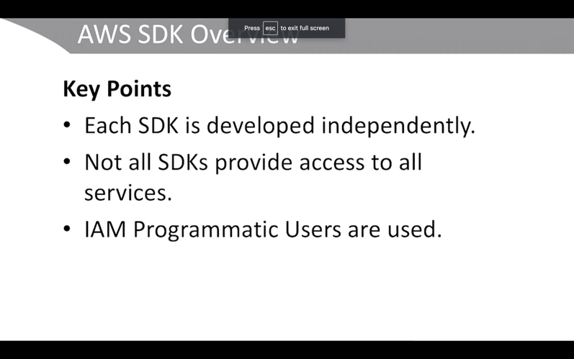

Is built on Python SDK called Botto 3

**Programmatic User:**

**Needed in order for CLI to work with AWS**

**Has permissions to everything if no permission boundary is set.**

**Give him administrative permission**

**Secret Access Key – hidden,** save it in the doc

**Console user**: Create a user in the browser

Configuration will show:

Aws configure – enter Secret Access key

Default region

Default output – json/text/table

That is the only time you will see the secret access key when you do first time

**Aws [Student$] cat credentials** will print :

Aws_access_key_id = fawgat57567yw

Aws_secret_access_key = feecy54w4q536

**AWS configure** commane:

Output = json

Region = us-east-e

When describing instances you also can choose to do it as query below. 

**Aws ec2 describe-instances** – will print in **json format instance array**

**Aws ec2 describe-instances –output text –query** – will return JamesPath query



**Aws shell** – interactive way of CLI, is like CLI but it gives command hints

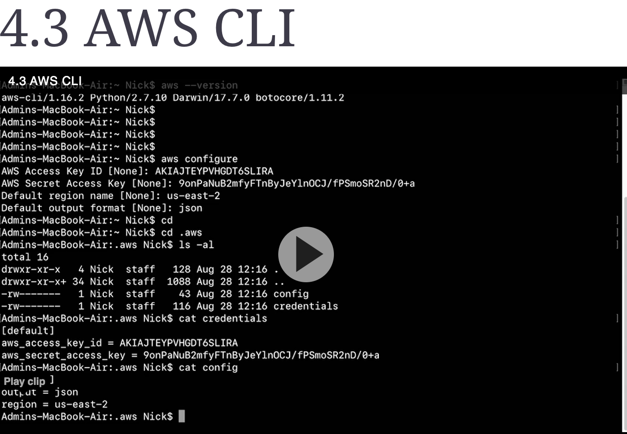

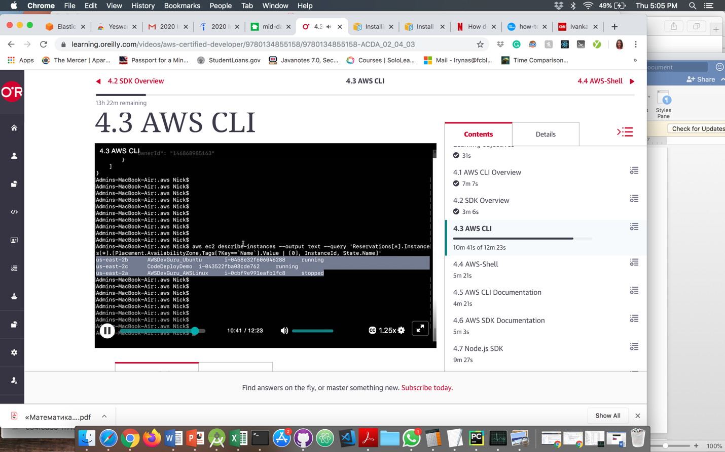

**AIM(Amazon Identity Management)**

IAM – create user accounts for either interactive or programmatic usage

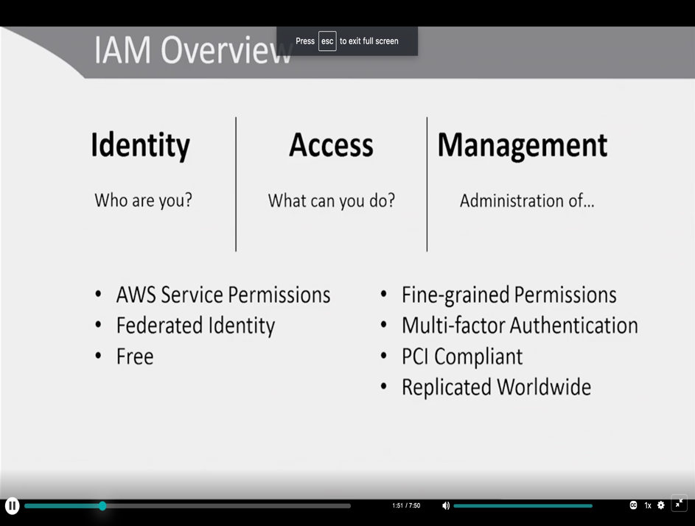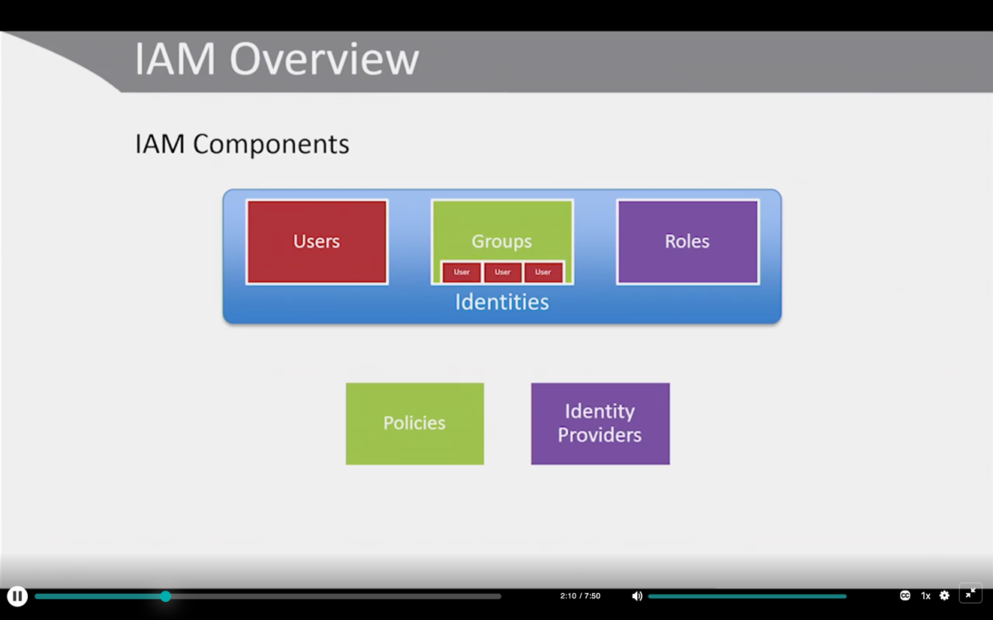

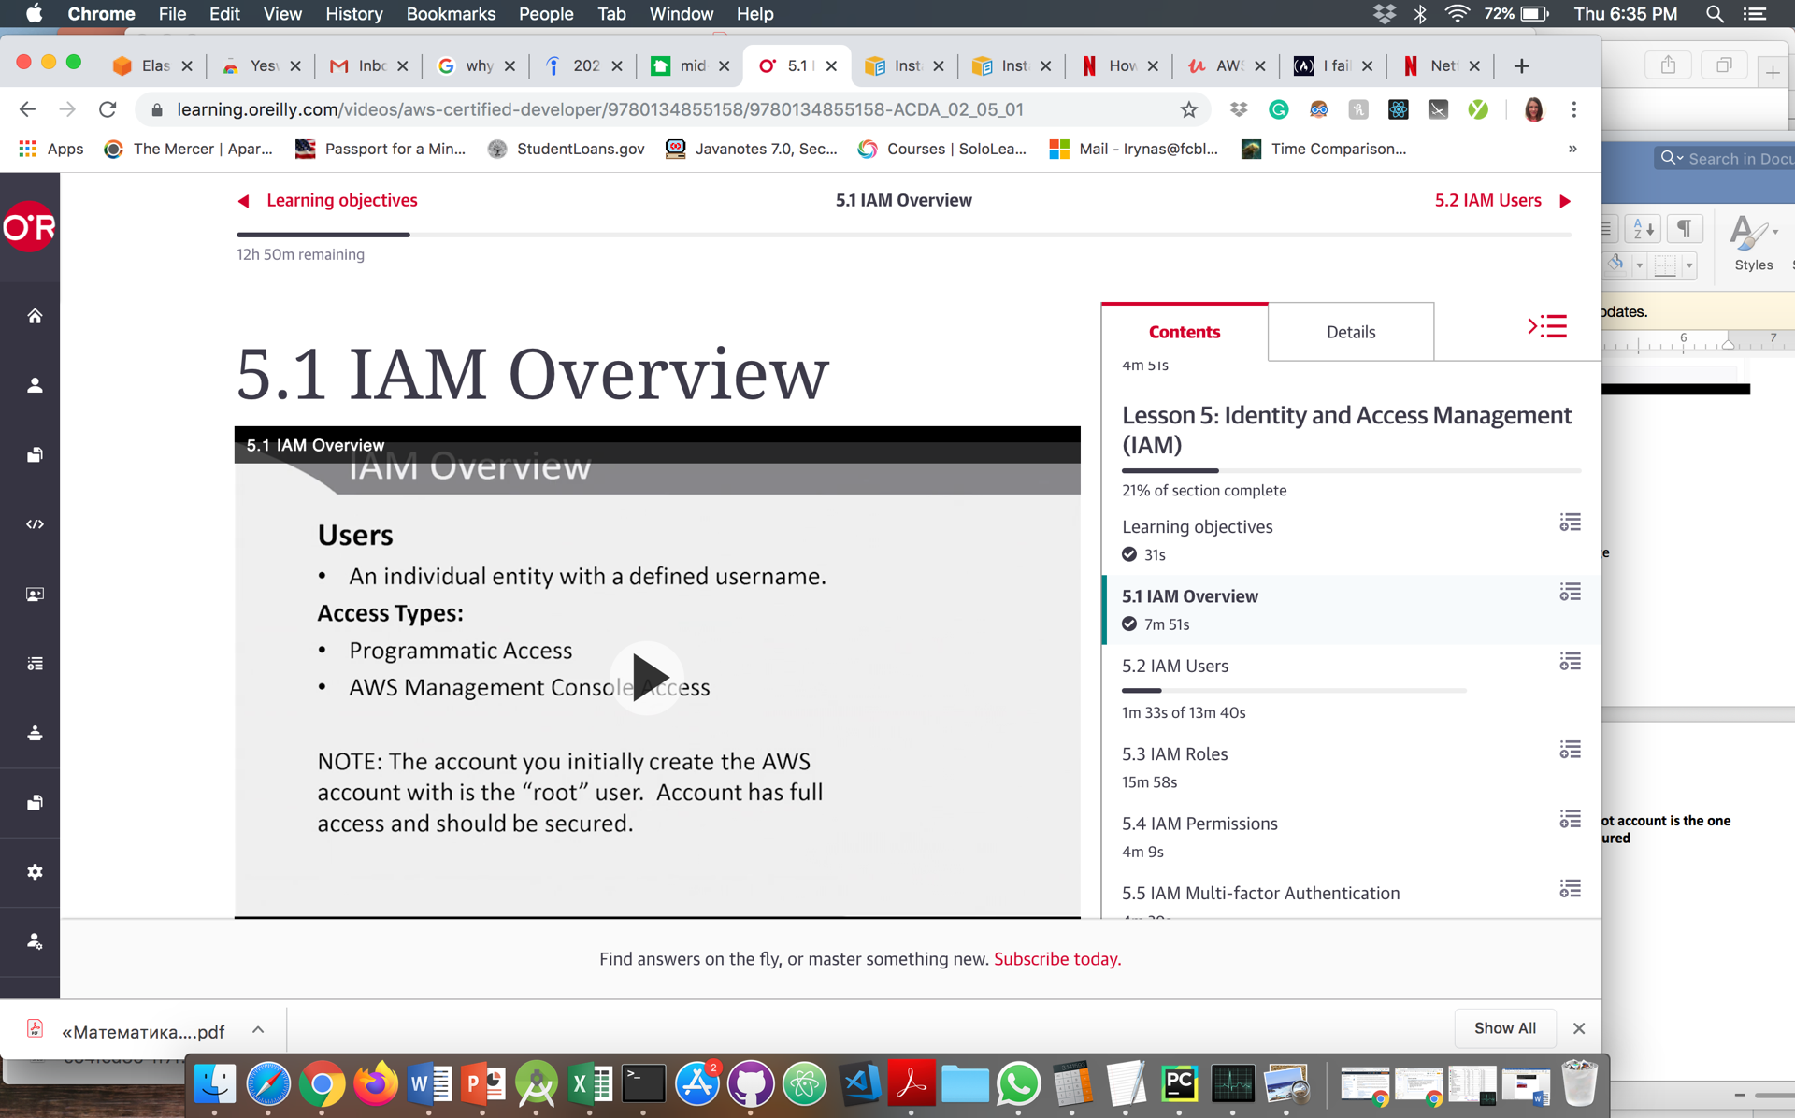

**Users**

**It is considered best to not use root account for security purposes.** Root account is the one when you create the AWS account. It has full access and has to be secured

First thing you create another user called admin and you store your root user credentials safe.

You can give a usesr a policy

Administrative – the least restrictive. It on of the AWS 367 policies, but you can create custom one.

Do not use * in permissions policies json as it allows everything

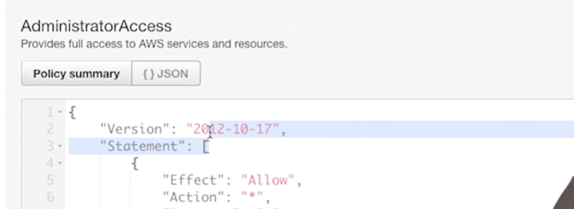

In the policy json the date on top is not when the policy was created but a version of IAM API, that way the policy won’t change it will always use the oldest one available

CLI command :

Aws iam create-user –user-name Alice

#Attach administrative policy

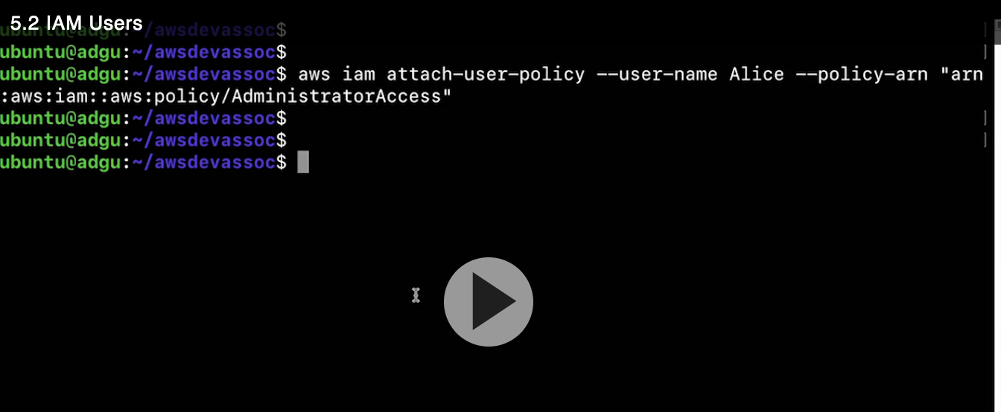

**Roles**

* **For a single person**
* **Or for a temporary access credentials to other services for example for EC2.**

**Credentials can be revoked when needed**

In the video example, the speaker created a config file for the S3 bucket and ubuntu EC2. But than this file needs to be distributed everywhere and this is not good. That is why it’s better to create a role in the console. There is user credentials in app.js visible too

AWS Role for EC2 instance: EC2_S#_RO(read only)

***Attaching a role to the EC2 without user credentials that have to be put into code***

Now you can launch another instance with that role attached.

For internal roles you can attached existing security group – only ssh and launch it

After that to log into EC 2 instance:

Ssh-I AWSDEvGuru.pem [ubuntu@13.58.252.0](mailto:ubuntu@13.58.252.0)

After that you can install node it it

App vi app.js

EC2 Metadata is attached to every running instance. Through scripting you can you ist for every instance. If you need info about instance you can talk to AWS to get that info though instance metadata.

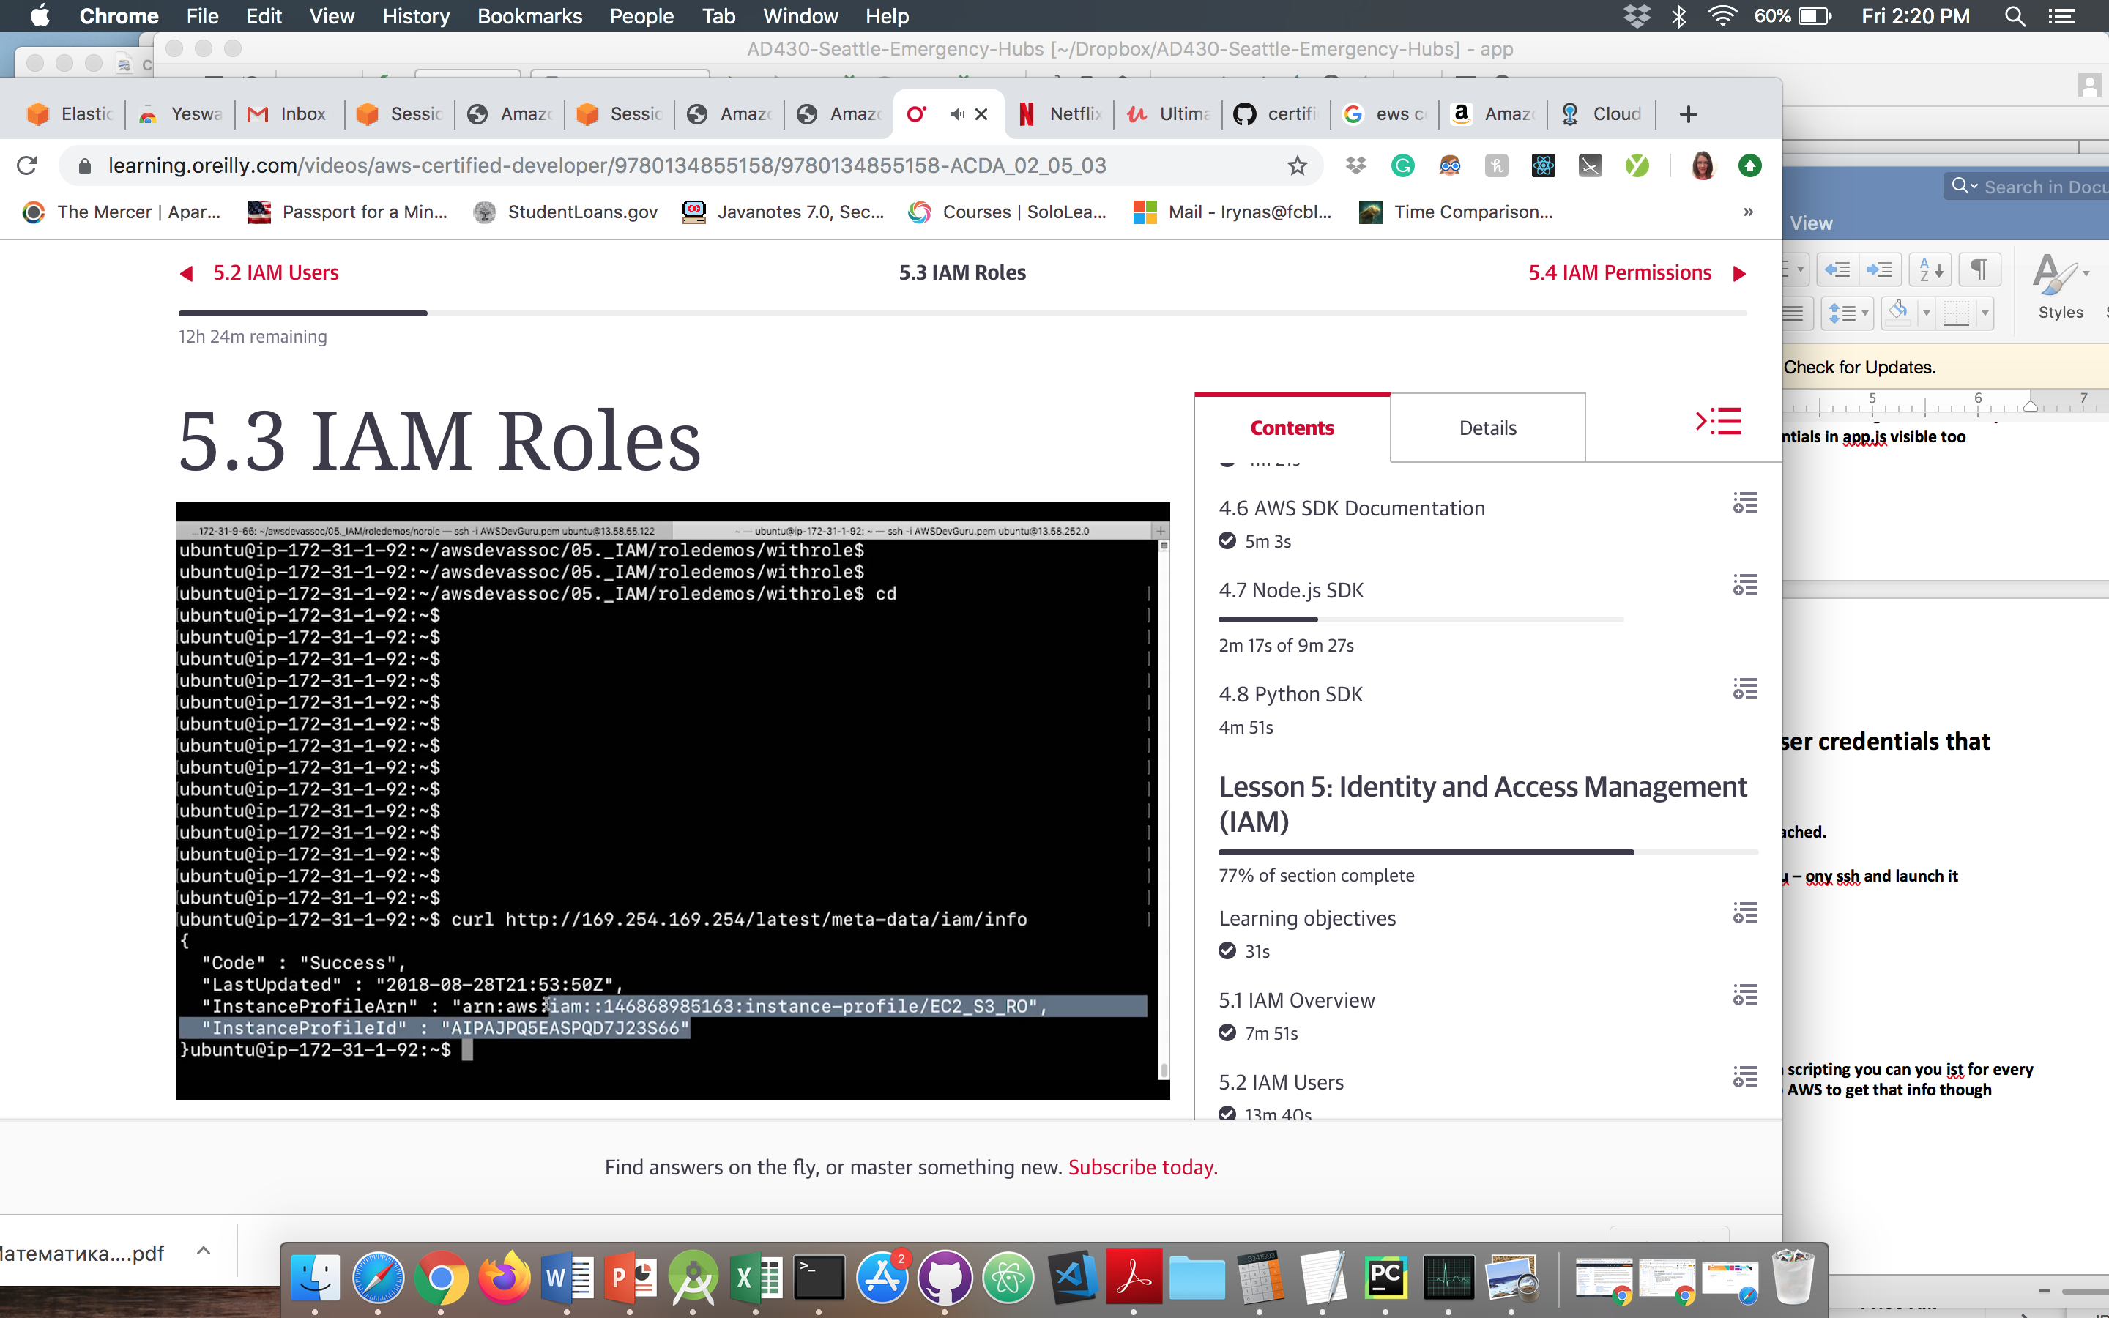

**It shows you an policy – EC2_S3_RO. You can use similar commands to view IP address for the instance:**

**Meta-data/local-hostname**

**Meta-data/public-ipv4**

**AIM Permittions**

***CREATING CUSTOMER MANAGED POLICY***

For example, read only information to billing service. So billing will have full information to read information.

Create a new user group – Finance.

In it, create a new user Jim – console user.

Add them to the finance group, and it will give you login link

If Jim will click on EC2 – it will be unauthorized. Only for billing the iam won’t authorize. So currently they do not have permissions to access billing info. If it was EC 2 they would be fine

You can log him in as a root user only to access billing information in the account setting option**.**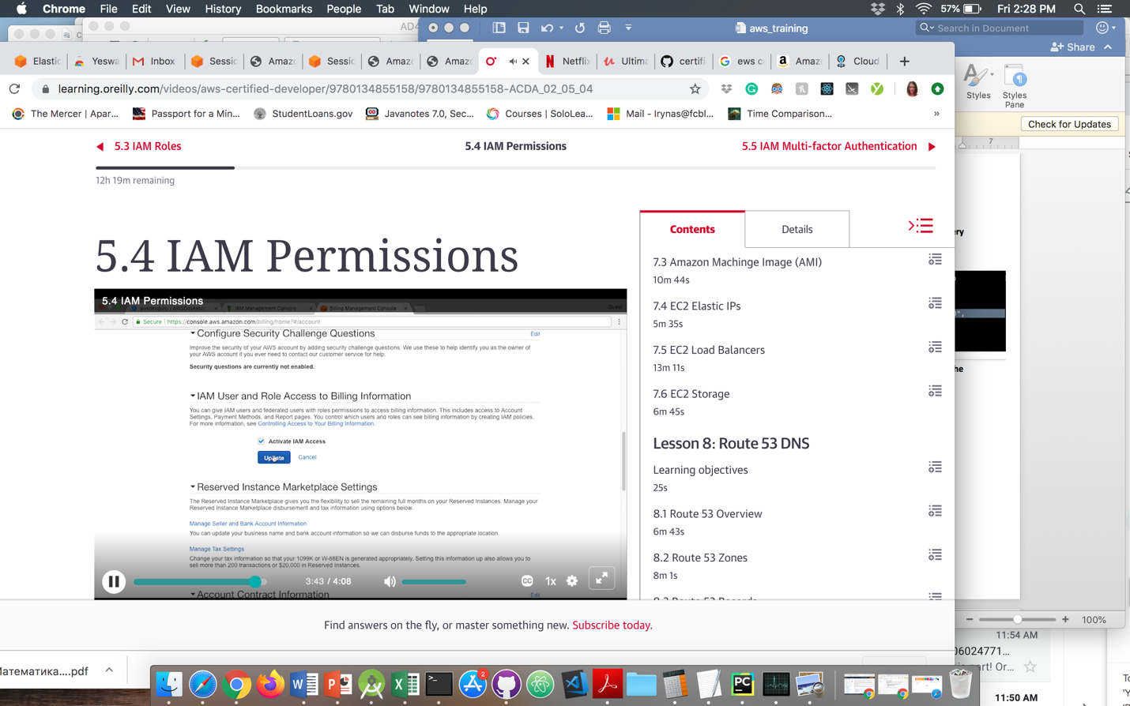

**After you enable it will allow Jim to access bills.**

**Security groups apply at the EC2 level and NACL at the network level**

**2 STEP VERIFICATION**

Create new user

Attache admin access policy directly

Create user

Inorder to unable 2-step V for this user there are 2 different token services

Click on user _> Security credentials – Asign MFA device – edit.

Virtual – rens on a piece fo hardware(phone) Google authenticator

So you just need to scan the barcode and the secret keys will be exchanged.

It will geve you + option – eter code or scan barcode.After you scan it will give you codes on a phone and then you enter them in the AUTH code 1

After your MFA device will be associate your device.

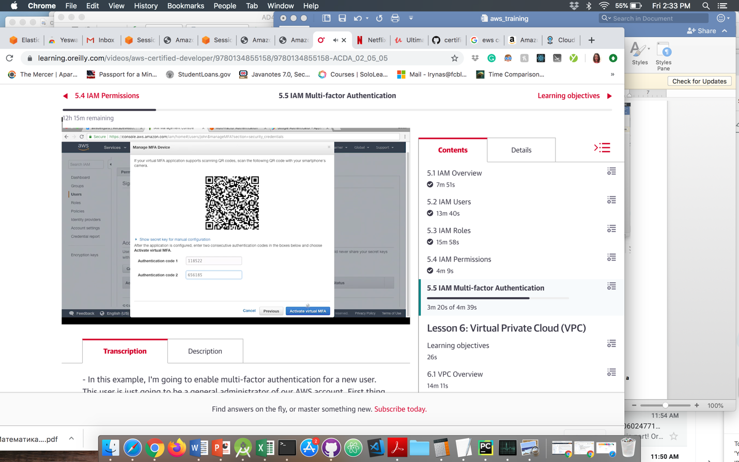

**It is best practice for admins to unable 2 step verification for web console admins**

So now you can go to johns account and log in as john and it will ask you for the MFA code

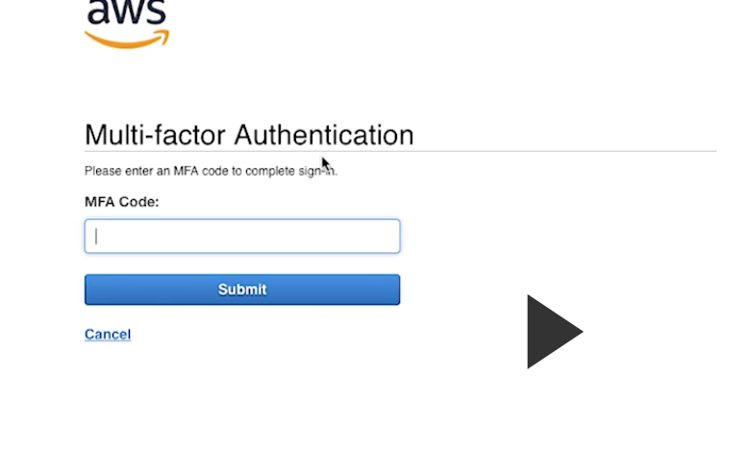

So john would have to open Google Authenticator and enter 6 digits.

VIRTUAL PRIVATE CLOUD

Gateway – Transition from public to private

If you have EC2 instance 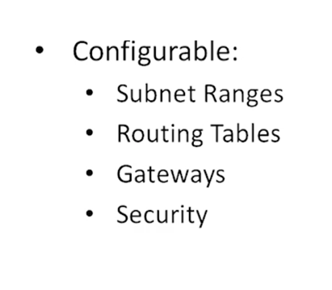

**Inside VPC – all private address space**. Translation from pr to pub is done via Gateway

These IP addresses are preserved across reboots.

**If you restart the instance inside VPC the private IP will be preserved.**

**The public IP could change though. You can deal with that with DNS**

For example if you have an instance that needs a leg into one subnet and another leg into another subnet, you can do it with **multiped network interfaces to one instance**

**NAL – Network Access List**

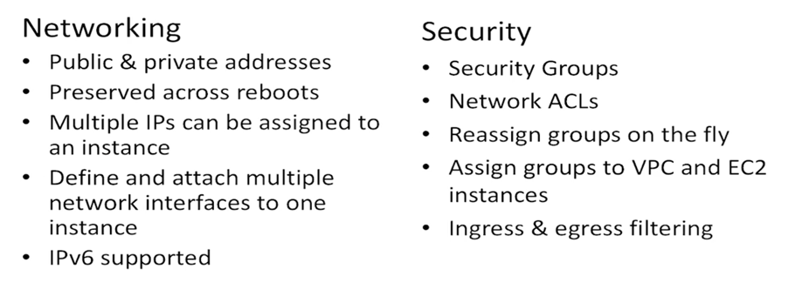

**For the security you have:**

* + **Security groups – for permit/deny source HTTP from certain sources.**
  + **Network ACL – for permit/deny IP addresses**

For networkACL – ingress and outgress filtering

When you create new account – it creates a default VCP for you. Non default – you manualy create

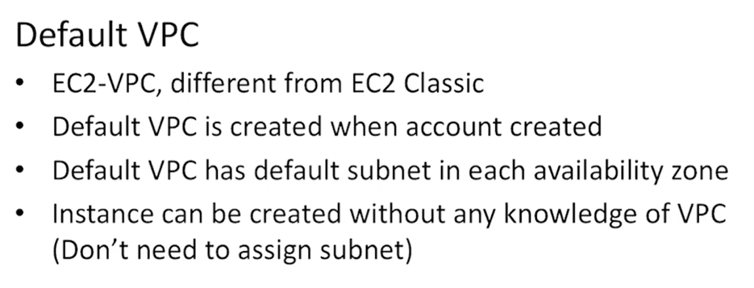

**NAT Gateways**. You can use a network address translation (**NAT**) **gateway** to enable instances in a private subnet to connect to the internet or other AWS services, but prevent the internet from initiating a connection with those instances.

If you are using NAT than the public IP f that host will become public IP for the NAT Gateway, rather than 1:1 translation of pr and pub ip for the EC2 instabce

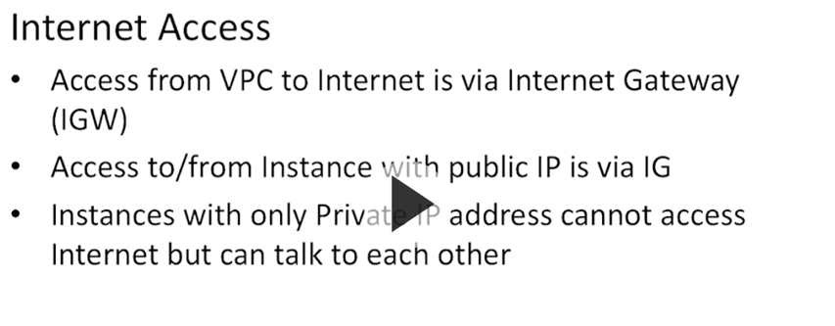

It is possible to launch EC 2 instance in a subnet and disable the automatic assignment of a publicly routable IP address. In that case just like any other layer the host in the subnet can talk to each other rhouth making harp, getting mac address and building frame

**You can use NAT gateways istead of IG if you do not want to assign a public address to an instance,** but you still need that IG to connect to internet

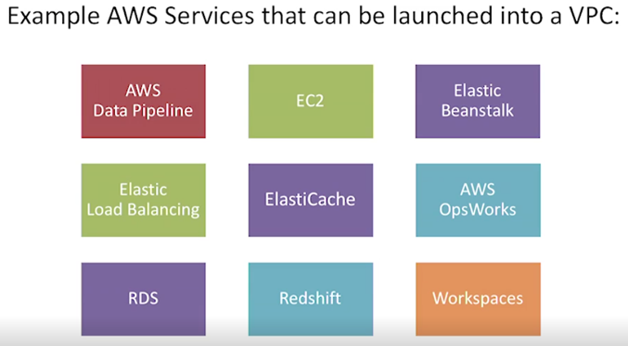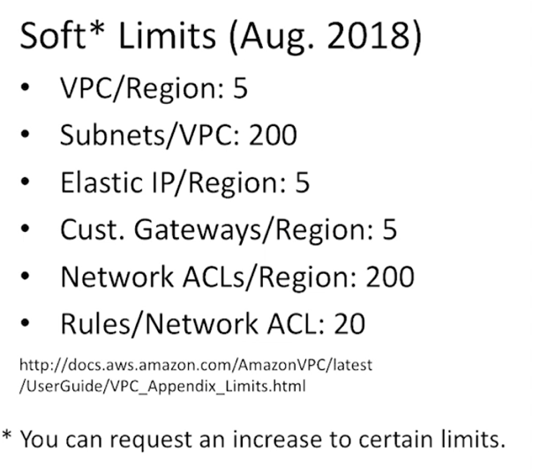

You can create VPC from CLI, but its complicated because you need to define a lot of things.

**VPC: $ FREE, but has charges with EC2 Instances, NAT, VPN connections. I fyou allocate and do not associate – there is a charge, but if you associate – no charge**

**VPC is inside a region, they spead across AZ;s in a region**

**Router:** You specify which side is which subnet sits on which side but you can’t log into.

It is a logical device.

**VPC is all about networking**

**Subnets – where our IP addresses sit. /24 – 254 usable usable hosts in the layer 3.**

**Route tables –** provided for you. Manage though route tables

**Security groups – allow/deny traffic**

**ACL –** ingress access list, outgress access list(NACLS) Acces conrol list

**NAT Gateway –** for the host, network address translation to allow by-directional comut. Private -> putvlic

**IG – public 🡪 private**

**Egress-Only –** allows traffic to access internet, but you don’t have ingress path to translate public IP to private IP

**Elastic IP – public IP that you can allocate and associate with something. It will always associated with that instance even after you restart it.**

It is helpful for DNS not to use aliases

**W8a9\**

Subnet address 173.20.0/20 – 1096 IP addresses. It is not recommended to launch 4000 EC 2 instances

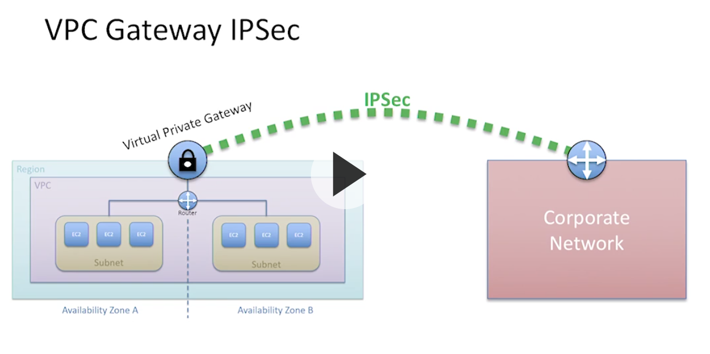

**Direct Connect**

**We can extend Laval 3 VPN cloud into Cloud providers You can install equipment there and exchange information between AWS and your network. Also you can install physizal security there to exchange between your network and AWS**

**Peering is completely logical, there is no physical device**

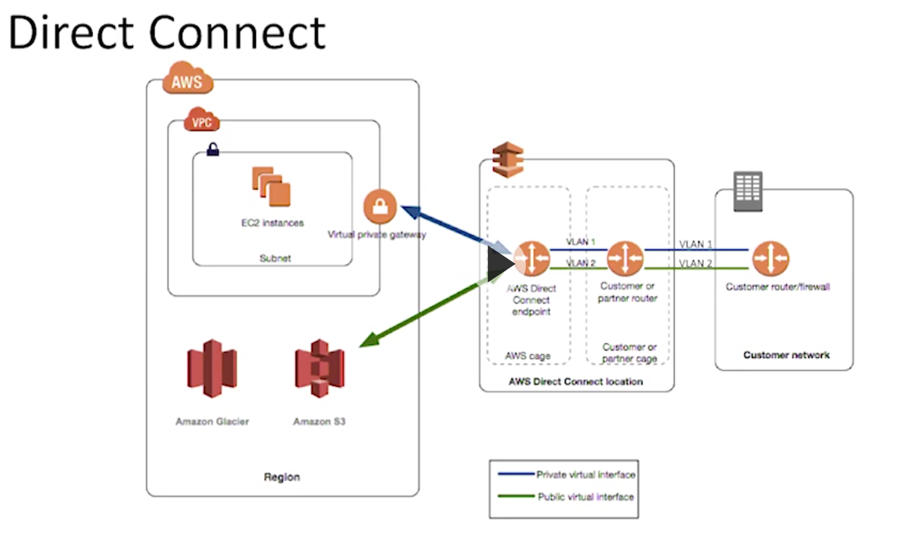

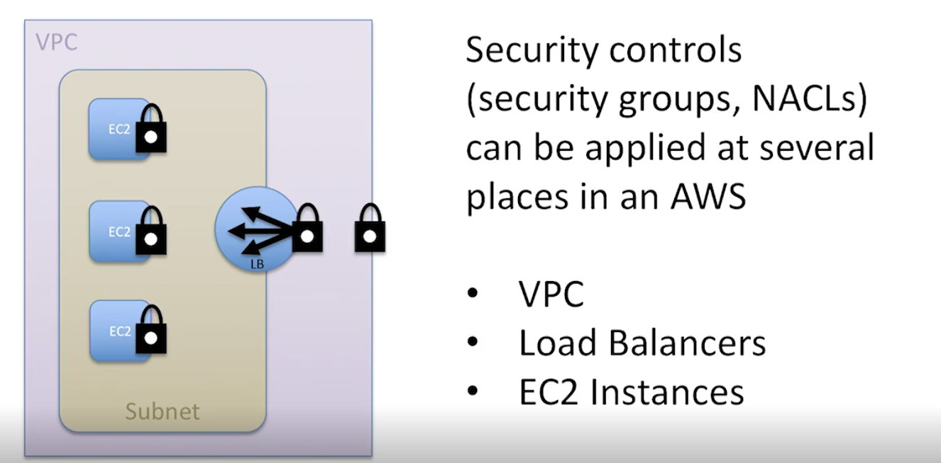

**Internet best practice – to filter traffic leaving your environment.**

**You are not expected to have ingress to something into VPC that is talking to something else in VPC**

**VPC security groups – vpc specific1**

My VPC for FC Bloxom route table

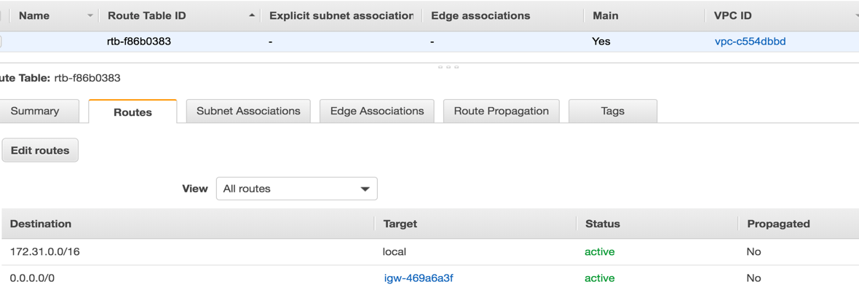

172.31.00/16 – subnet   


**Elastic IPs – addresses you can allocate and associate with any EC2 instance**

Endpoints used to connect to other services. If we want to connect secure to

Security groups are associated with VPC. The web console will only show you the groups as being available for the VPC you are attaching the instance to

**After we created a Privatel Subnet, we don’t want Private Subnet to auto assign public IP’s to instances in that subnet – - than auto-assign IP on Subnet Public. Go to Modify auto-assign IP settings.**

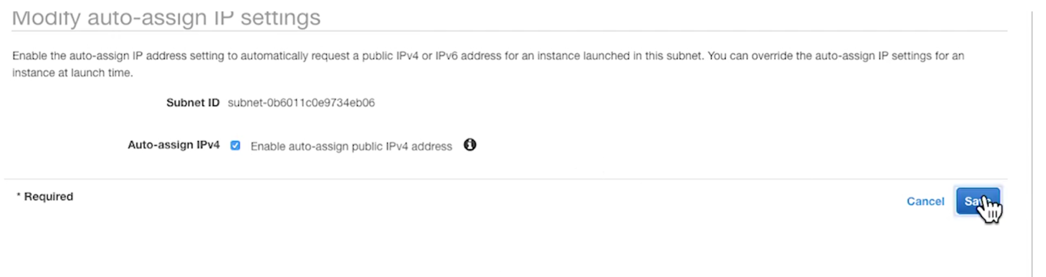

**Next thing we create and Internet Gateway so hosts in the Public Subnet will have access to the internet.** We will attach this to the **ProdVPC.**

**UJYJ**(need to go back and look up the id for it)

NAT Gateways -> Create New-> Select public _> create new Elastic IP and enter subnet.

Then go to route tables and associate this private subnet explisitely with a private route table.

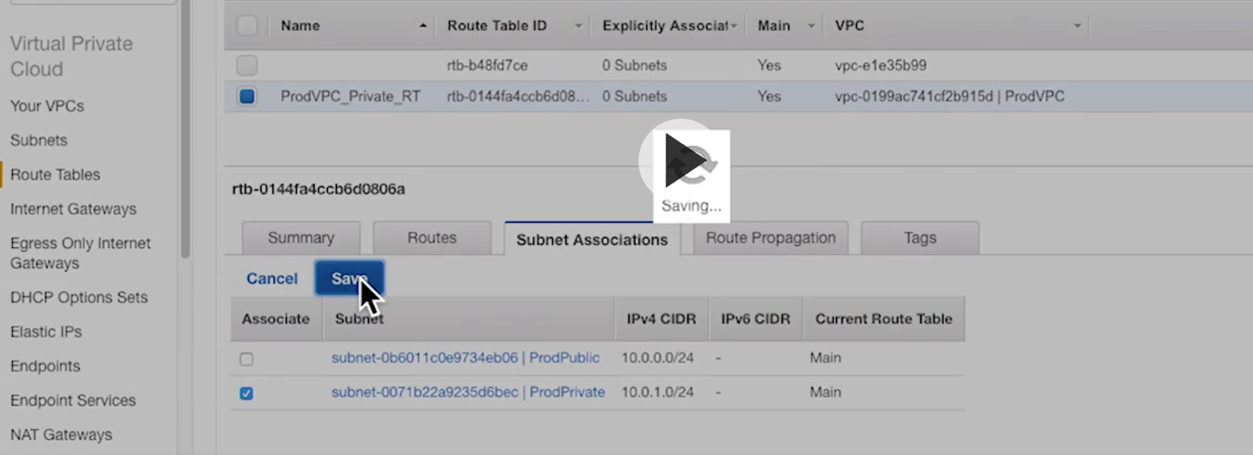

**Then in order for PrivSubNet to connect to internet through NAT Gatewayy=, we have to create a new route – Destination - 0.0.0.0/0**

Target. – NAT Gateway

This is our Private Route Table

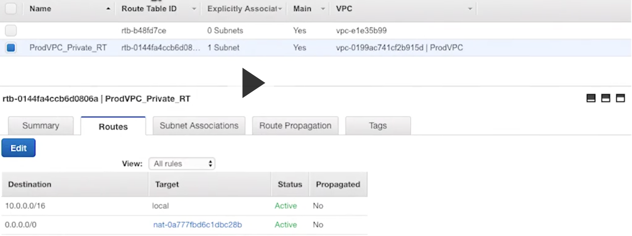

Now we need to create a Public Route Table

Create - > give name & Associate with our VPC

Associate it with a public subnet

Now we need a default route pointing to the Internet Gateway

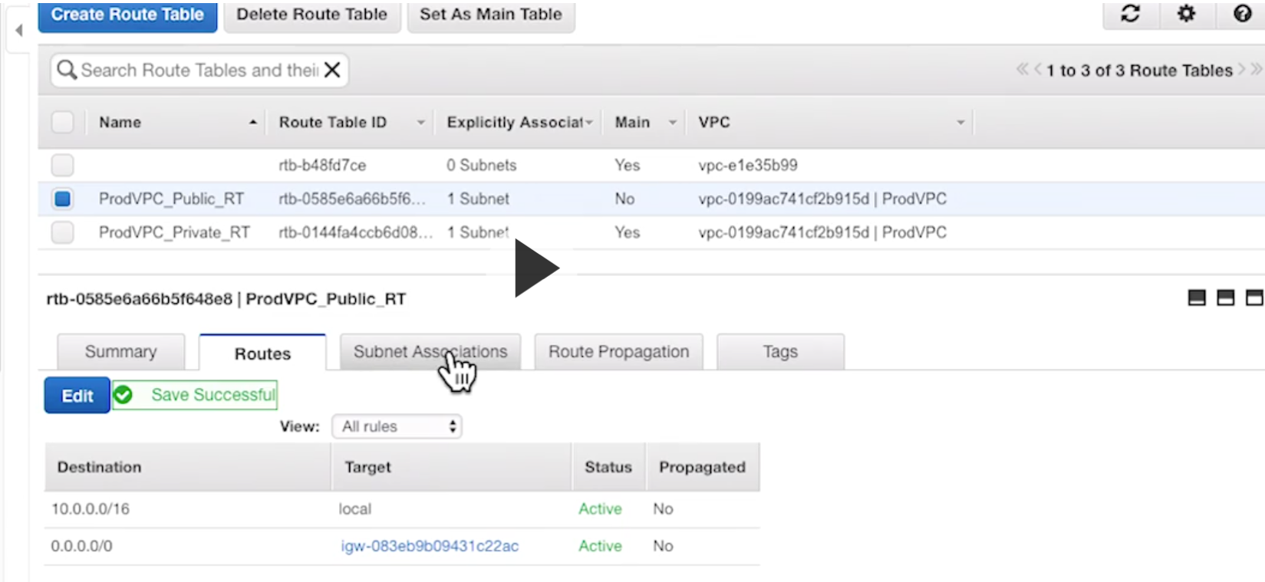

The last step in creating VPC – **Access List**

Create new Network ACL or edit the existing

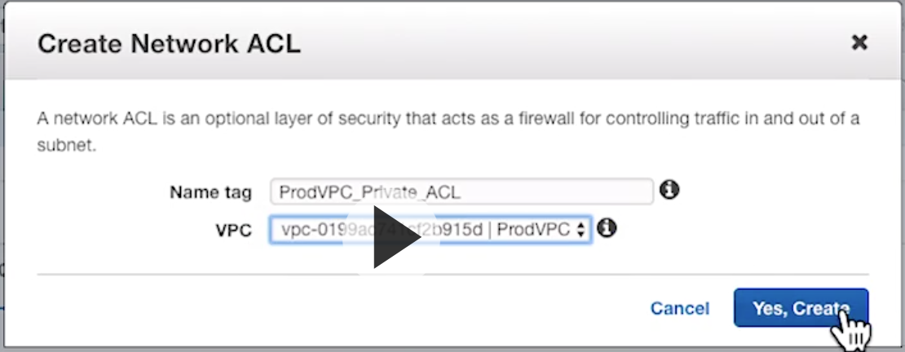

**By default you will get deny all rule.**

**Create a 100 rule**

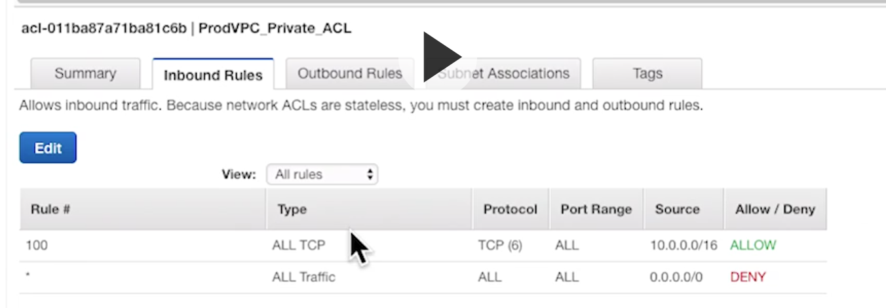

**Created an inboud rule that permits all TCP traffic from sourse 10.0.0/16. So it only permited only if its from our source.** It has to be sourcRDDFTed only from our VPC.

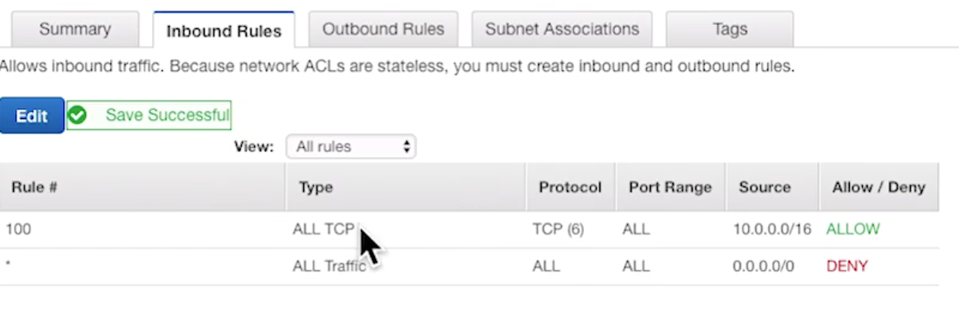

Jump server – for administration of the instances

Question:

Hi, I just did the Mega Quiz, and I didn´t understand the correct answer of the question below. Why should I add an EIP to the 3rd instance to be able to receive internet traffic? In my opinion I would have to check port 80 at Security Group level, since all instances are in the same subnet (so ACL must be ok).

Question:

You have 2 EC2 instances which sit in a custom VPC in a public subnet. These instances are able to receive internet traffic. You add a 3rd instance to the subnet, but it cannot access the internet. What should you do?

1. Move the EC2 instance in to another subnet.

2. (Correct?) Answer Add an elastic IP address to the new instance.

3. (Incorrect?) Enable port 80 on the security group

4. Check your ACL permissions

Decompose the question--2 EC2 instances running in a public subnet of a custom VPC are able to recieve internet traffic**. If 2 EC2 instances can successfully receive internet traffic, then the SecGroup and ACLs are configured correctly--this eliminates answers 3 & 4.**

You add a 3rd EC2 instance to that subnet and that instance CAN'T access the internet. Now you can conclude that something is wrong with this 3rd instance in particular. You could move it to another public subnet, but if some instances work in the first subnet then any instance should be able to. This removes answer 1, leaving only answer 2--add an EIP to this 3rd EC2 instance.

Analyzing from the other direction**--its possible to set the default action for a subnet to NOT assign public IPs to the instances launched into it. An instance without a public IP won't be able to access the internet. The only way to assign a public IP to an instance without one is to attach an Elastic IP**.

Workflow

For Alastic Load Balancer you have to have 2 subnets across 2 AZ

For 2subnets in the same AZ – Network Load Balancer

If your web server does not connect to the internet, but you do have Internet Gateway, that could mean that your server doesn not have public IP address. Go to Elastic IP’s and allocate new IP and associate it with web server.

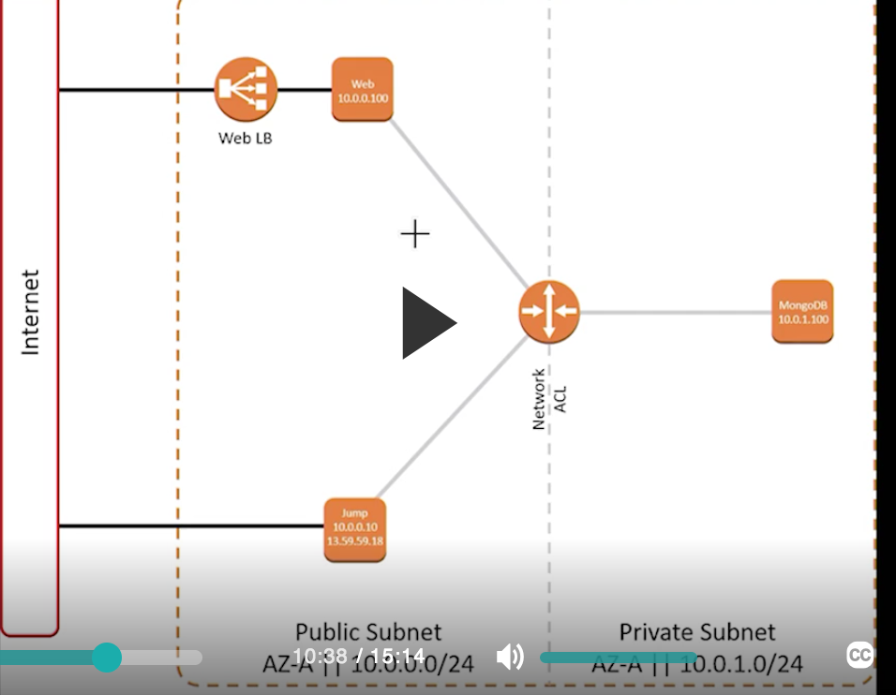

You can later disassociate that Elastic IP(release it) later so you don’t pay for it.

Load Balancer should work fine after it gets 3 succesful connections to that instance on port 80.

If we copy the DNS name and paste it into browser, its going to fail because of the health checks of load balancer. You can check it n to Load Balancer target groups that it is unhealthy.

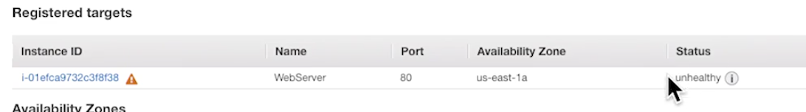

EC2

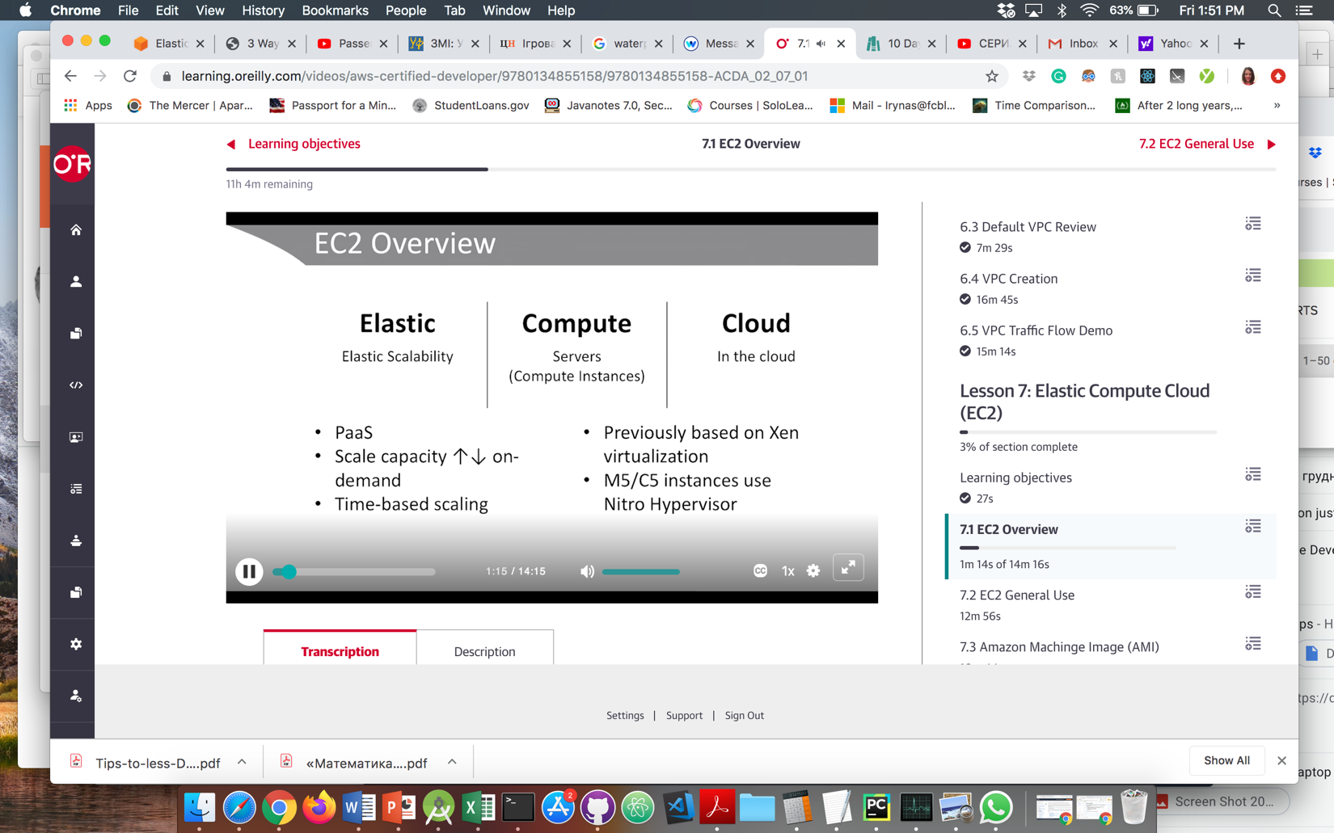

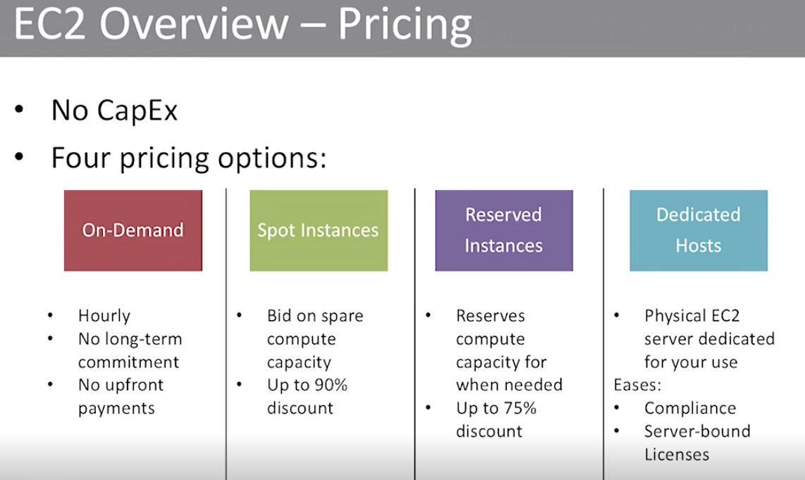

Pricing is per region

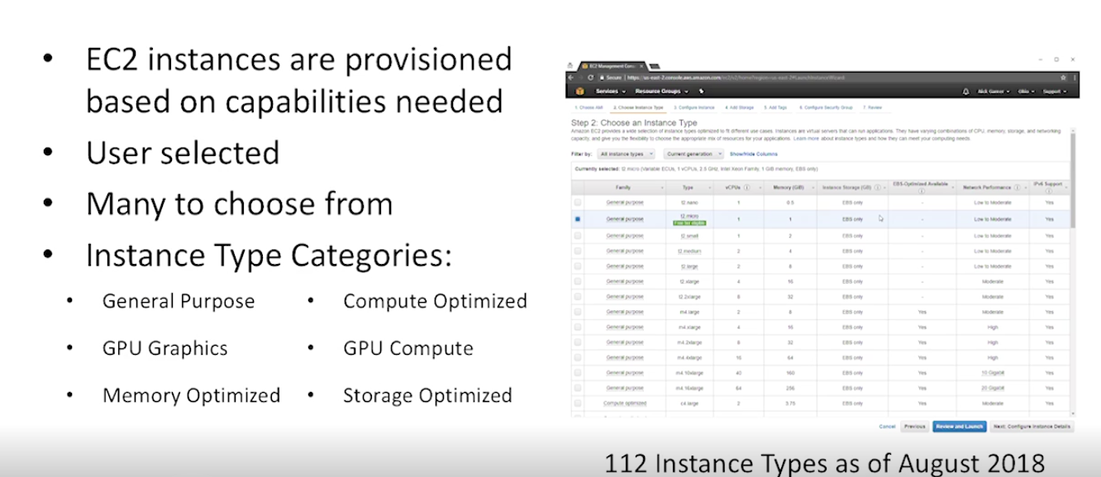

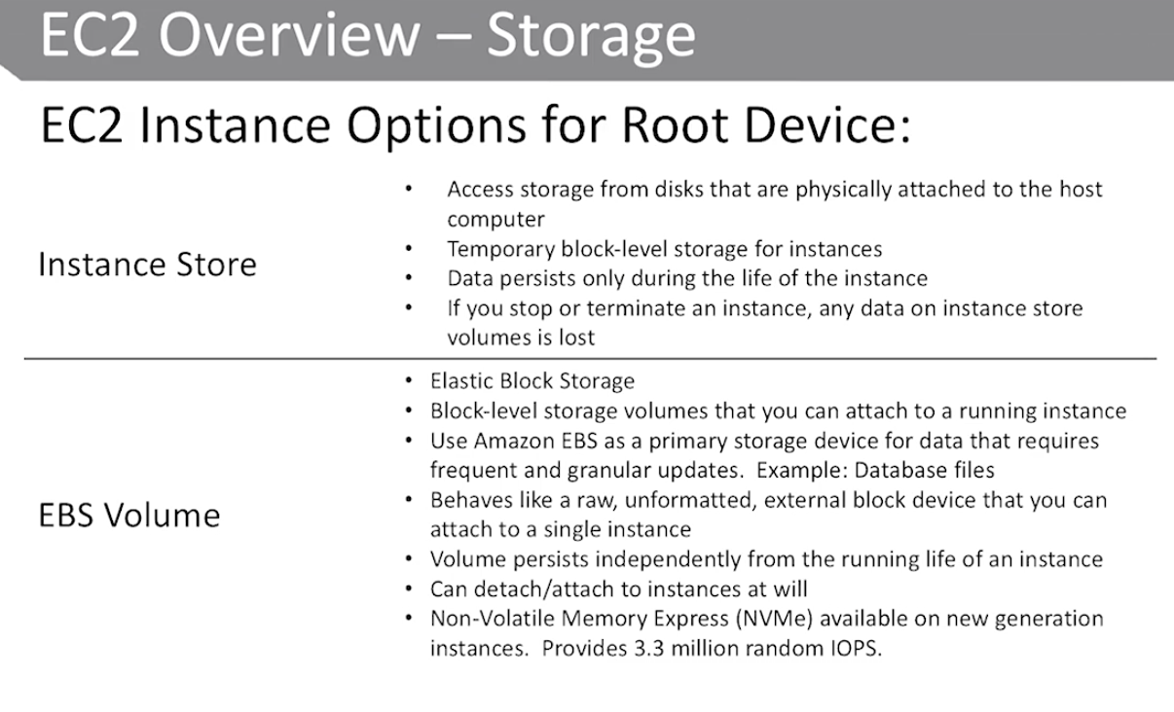

Difference – Instance Store – you loose it while shutting EC2. EBS – you can attach to a different instance

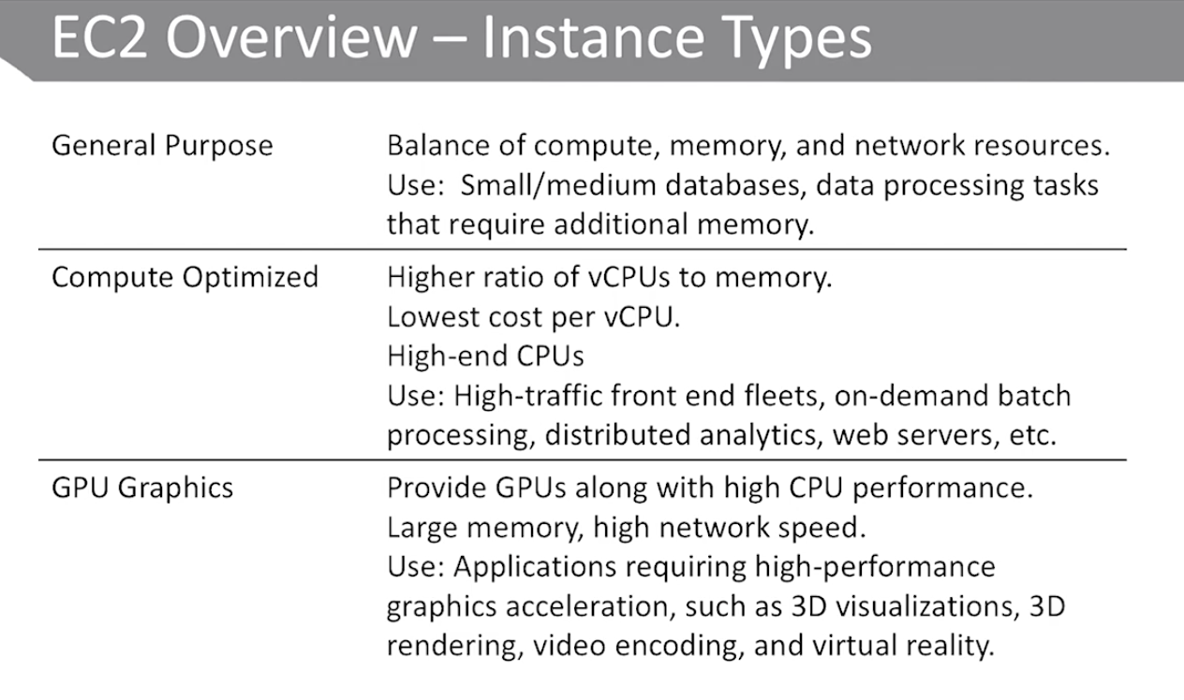

Termination protection – will not alow click terminate.It will be greyed out and you have togo to settings -> change termination protesction and then it will allow it.

**AMI**

Eslastic IP- youwill have sae IPeverytime

* Allocate
* -Associate

EBS Volum – cannot be shared across regions AZs

DNS

Why is Route53 named as such?

DNS port is 53

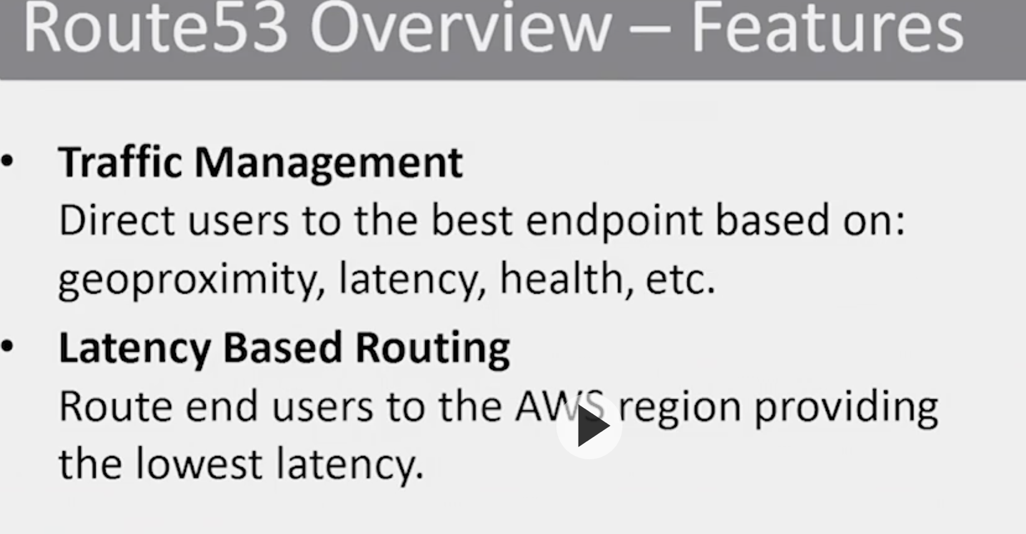

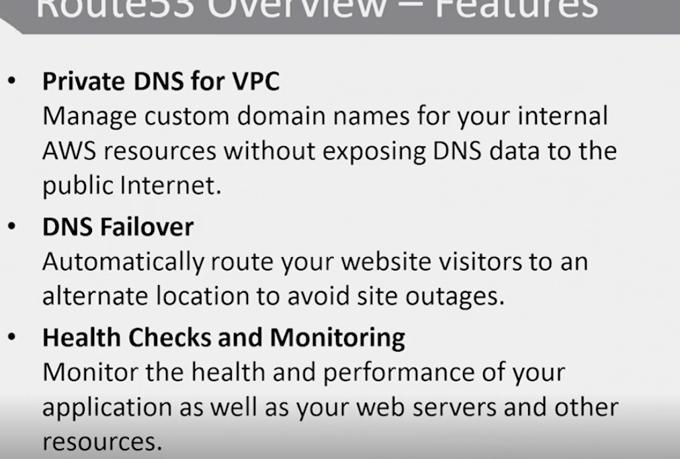

**ELB integration – you can associate a record set with alias and the LB can say – send this to this or other IP.**

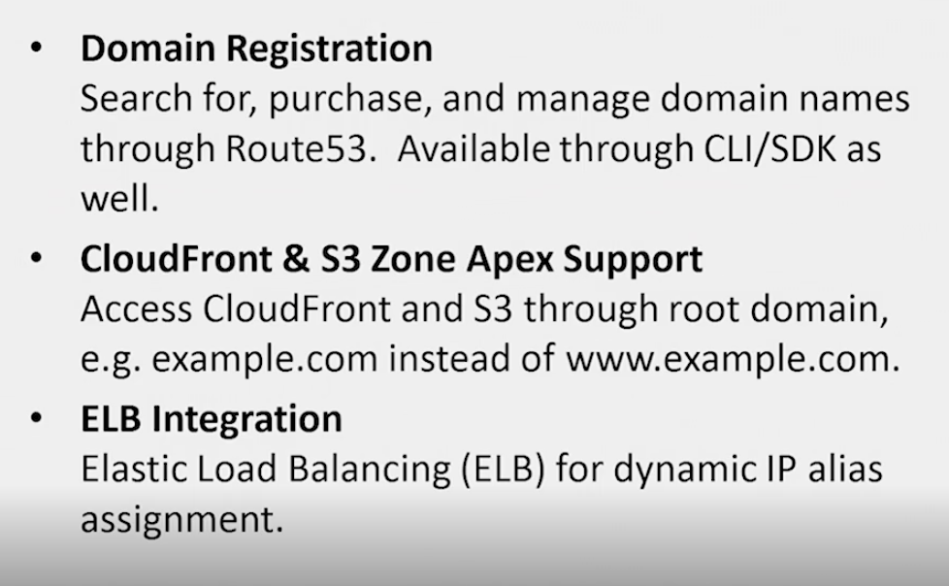

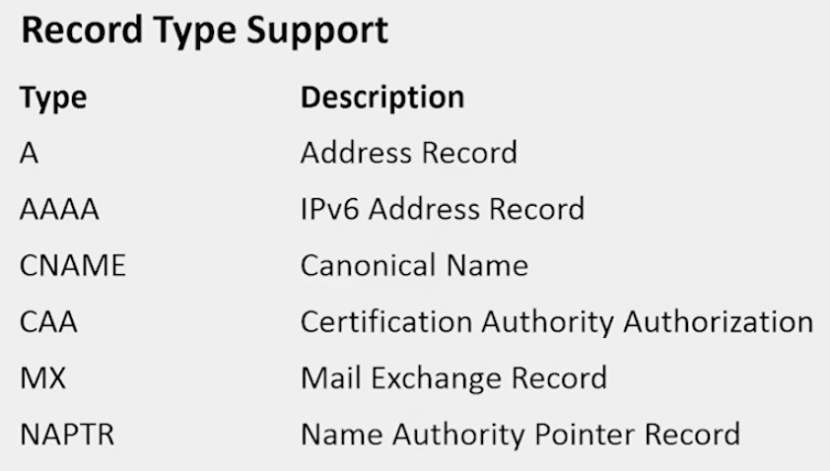

**Hosted Zones**

**You can create as many hosted zones as you want, but it doesn’t mean that they will be working. They have to be:**

* **Registered domains**
* **Name servers for those domains need to point to amazon servers**

For example, if you enter **awsdev.guru** you can see there is 4 ns records for this name and they go to aws dns and some sort of identifier.

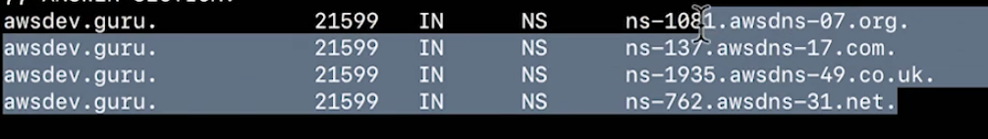

When you create a zone, they will tell you what name records to add in the zone

**When you create a zone, remember these zones don’t accualy have to exist.**

Then you can create record sets for that zone.

When you create a zone, they will tell you what name records to create.

It creates :

**Name server record** – we will get names that we will have to enter in order for root,.com to point to amazon

**Registrar of authority**.

**You can also register domains at AWS**.

Aws route53 – help

Aws route53domains help

* Domain – can tell you that the domain is unavailable.

**Awsroute53 list hosted zones** – will show this info

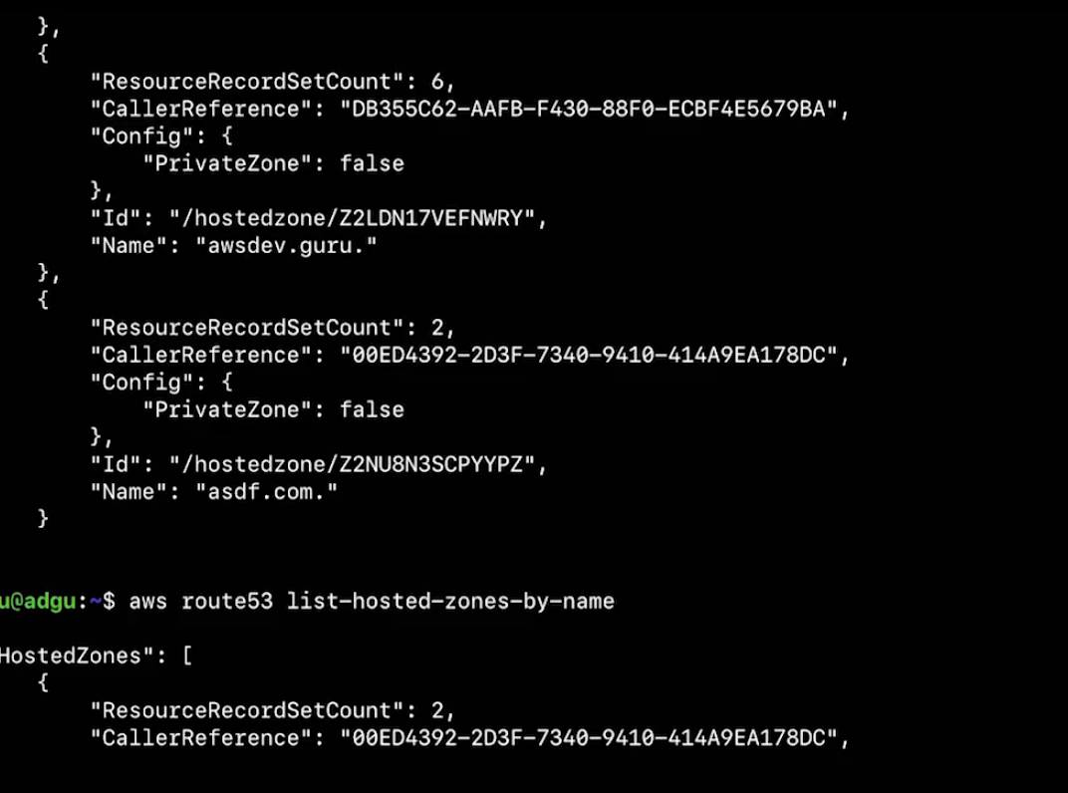

You can create hosted zone with the CLI.

**DNS records**

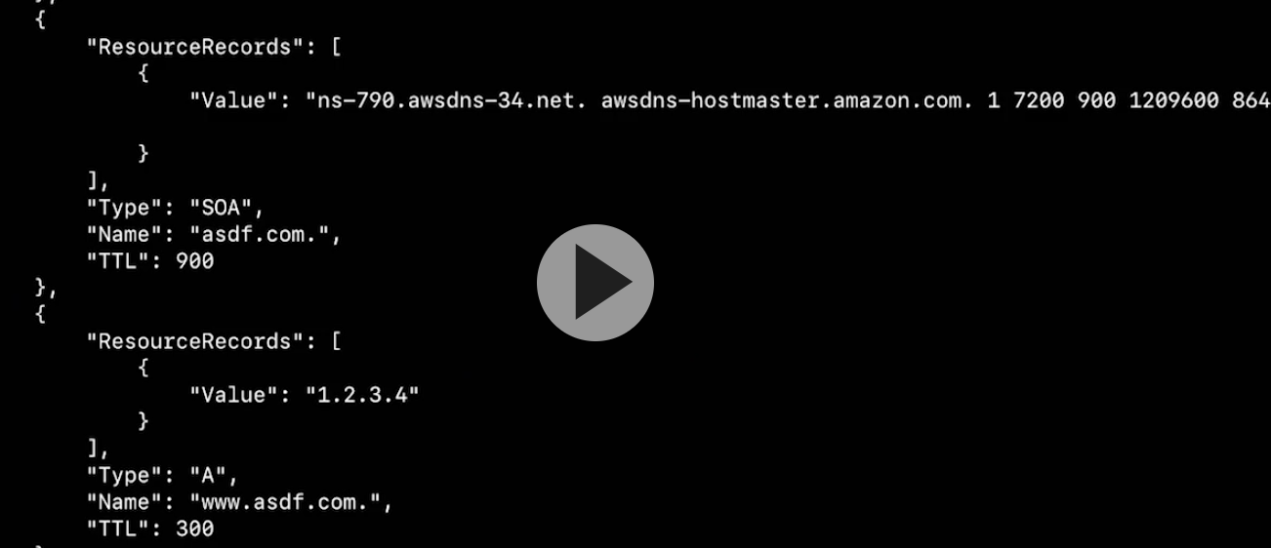

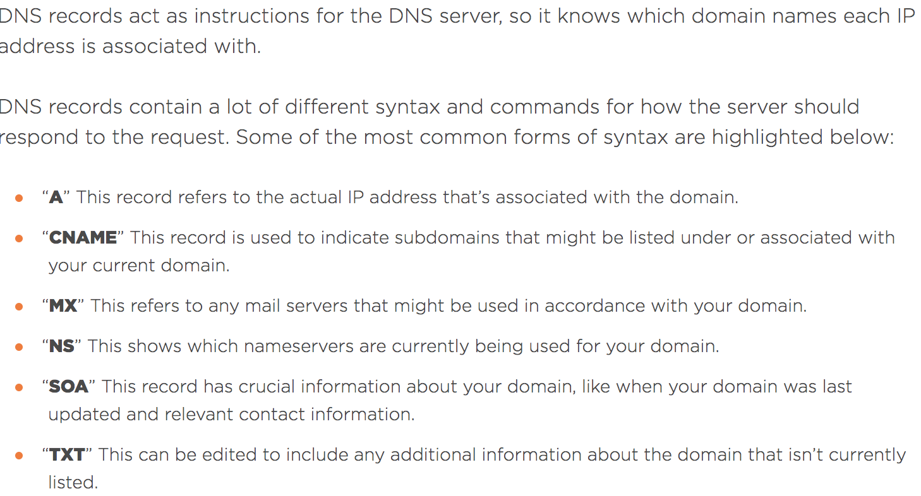

**Route 53 Aliases**

**Alias – you can associate domain/subdomain name with the alias that points to the LB. So you can associate awsdev.guru to that load balancer.**

Apex zone record points to the LB

**Route 53 Policies**

**Based on the policies you can direct Europe traffic to the Europe servers.**

**Create traffic policy.**

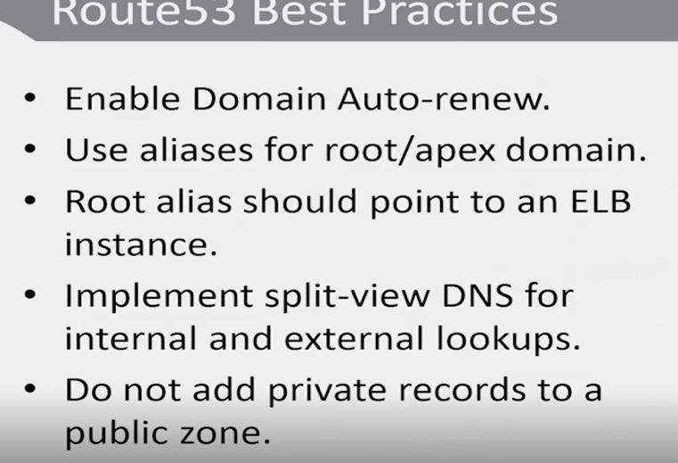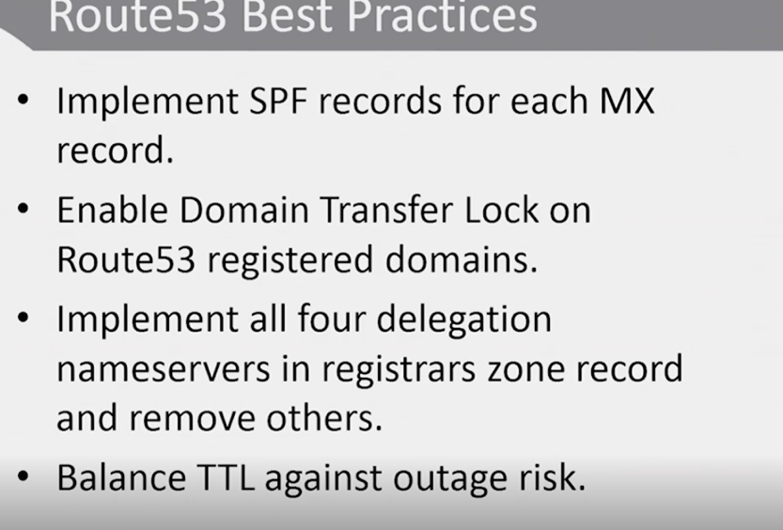

**TTL (60 sec) – request is going to sit in cache for 60 sec**

**After creation in the video – Record A – traffic policy record**

**Route 53 Best Practice**

**If you register domain, turn on auto renew, we do recoment using aliases**

**When oyou create domain in route 53 it gives you 4 d servers. You should take them and put them in the zone and remove others**

Q. What is the default TTL for the various record types and can I change these values?

The time for which a DNS resolver caches a response is set by a value called the time to live (TTL) associated with every record. **Amazon Route 53 does not have a default TTL for any record type. You must always specify a TTL for each record** so that caching DNS resolvers can cache your DNS records to the length of time specified through the TTL.

**TTL – if you can’t be down for 5 min – do not use 5 min TTL.**

**Can I associate multiple IP addresses with a single record?**

**Yes. Associating multiple IP addresses with a single record is often used for balancing the load of geographically-distributed web servers. Amazon Route 53 allows you to list multiple IP addresses for an A record and responds to DNS requests with the list of all configured IP addresses.**

<https://aws.amazon.com/route53/faqs/>

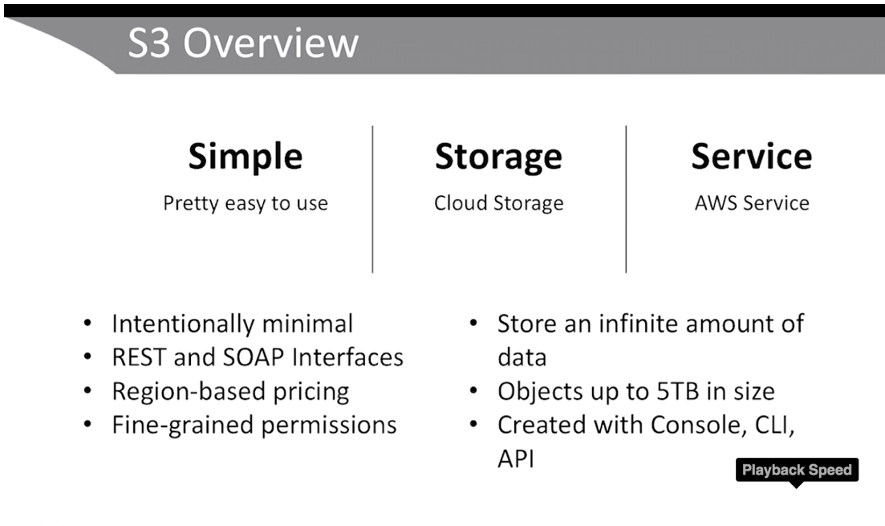

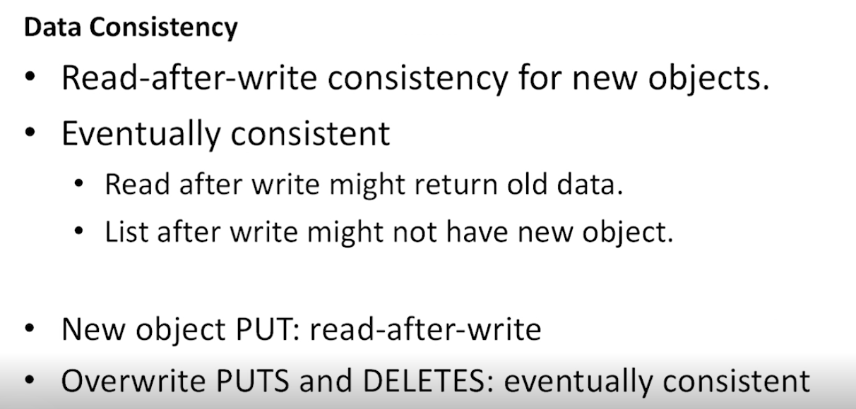

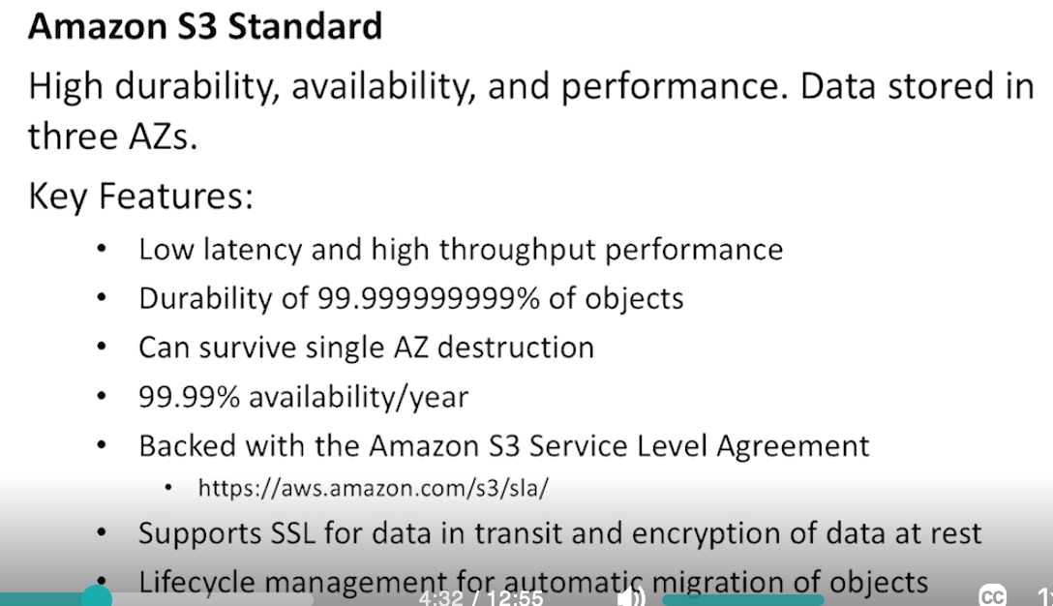

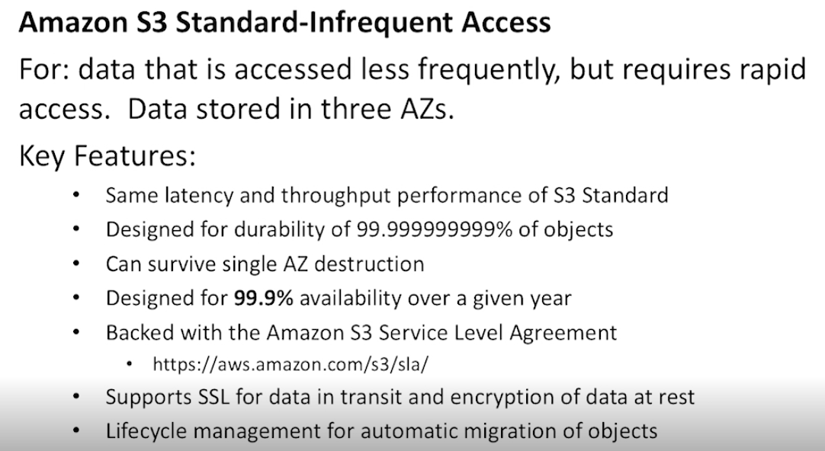

**S3 Security**

**Buckets**

**Items in buckets**

**Simple Que Service (SQS) – serverless server for decoupling application on demand for apps that process messaging. We can use SQS in front of application. Those requests for processing will build in the queue.**

All messaging services

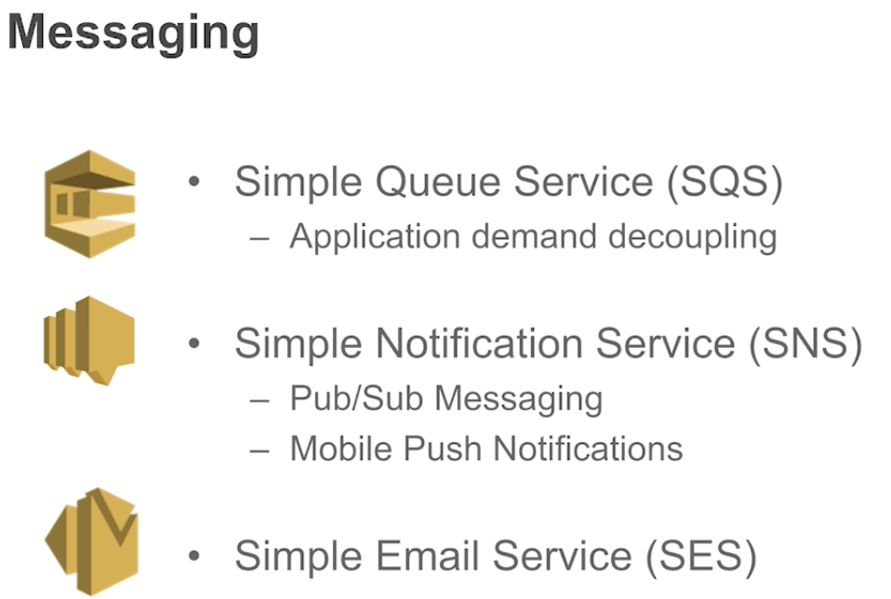

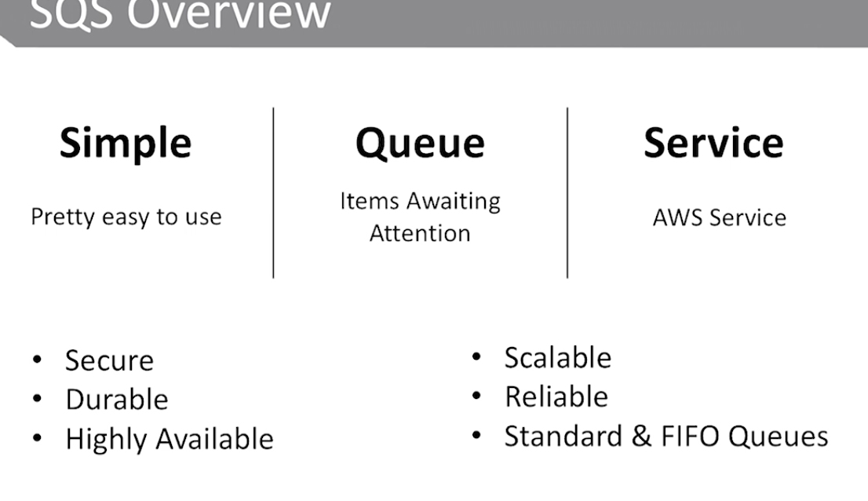

**Secure – Server Side Encryption**

**Durable & Reliable – across multiple buckets**

**Scalable – millions of messages**

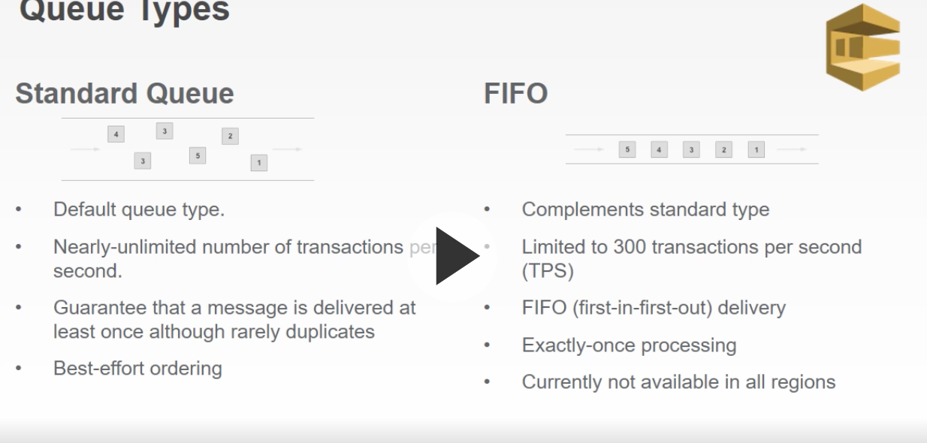

**SNS – for sending messages to people who subscribed to some SNS topic.**

**SQS also can grow too large and crash, so to avoid that we can launch the auto scaling group + cloudwatch metric to notify to scale out . This wil be optimized for performance ad price**

**CloudWatch metric based on length of SQS**

**If you have a bug that doesn’t process messages – send notification to admin that SQS queue grew too large.**

**If you send bulk emails – to avoid spam – request a Sending Limit Increase**

You fill in the form and send it to AWS support.

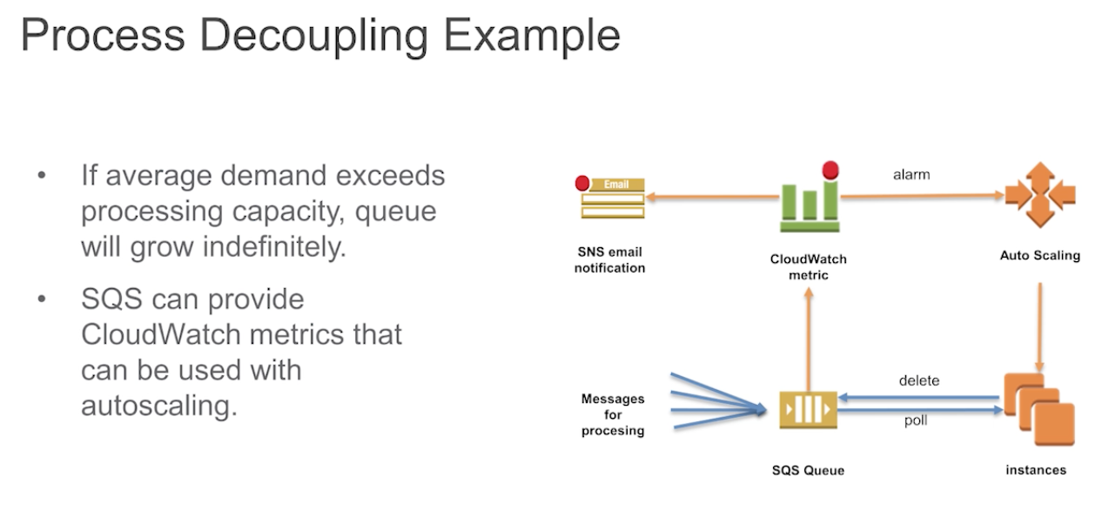

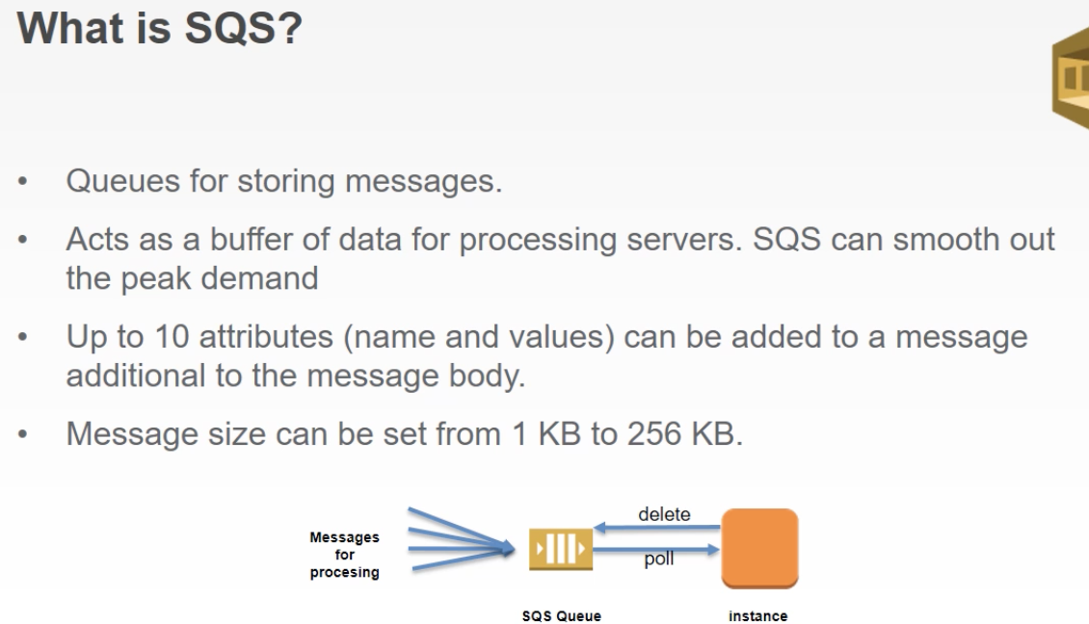



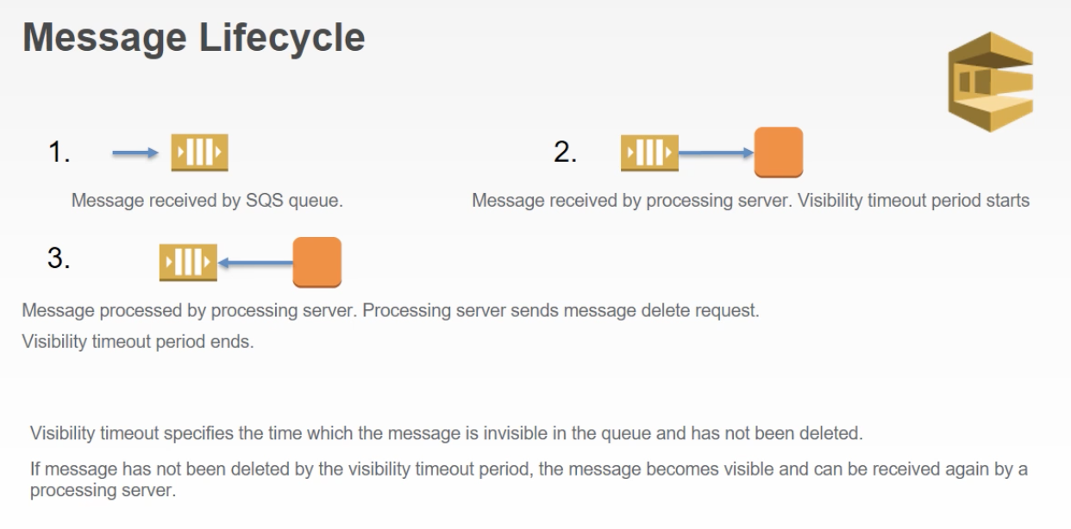

You have to make sure you process messages in your application within the visibility timeout period, otherwise it will go back to SQS

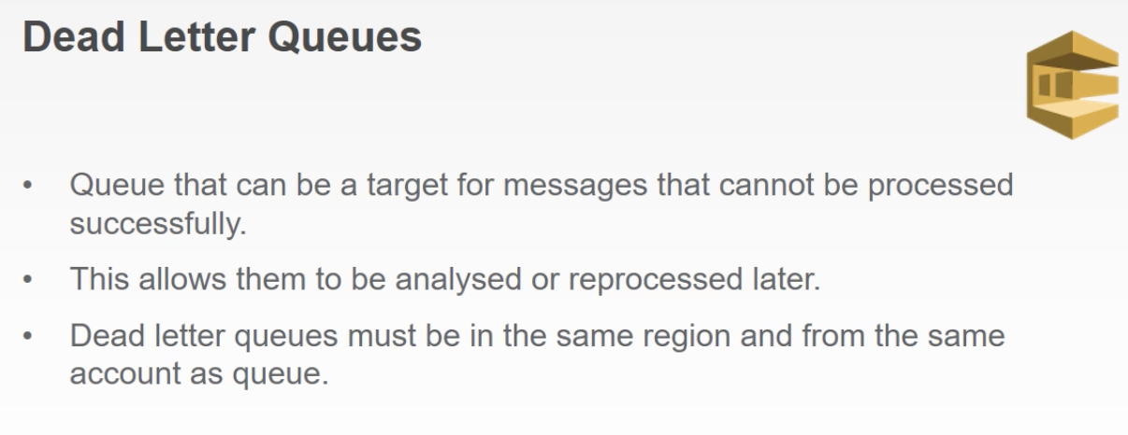

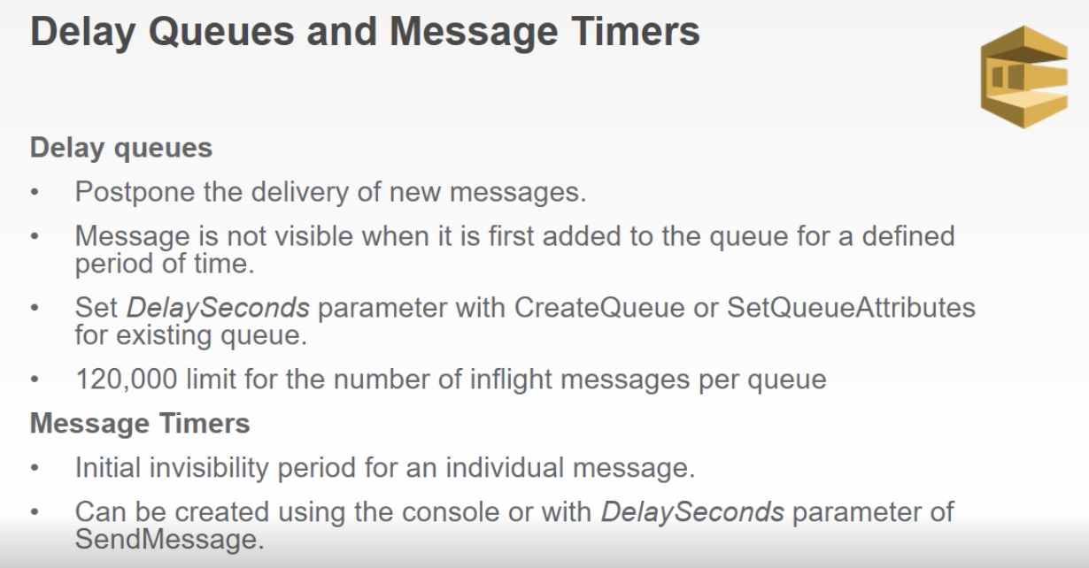

**Note**

For standard queues, the per-queue delay setting is *not retroactive*—changing the setting doesn't affect the delay of messages already in the queue.

For FIFO queues, the per-queue delay setting is *retroactive*—changing the setting affects the delay of messages already in the queue.

Delay queues are similar to [visibility timeouts](https://docs.aws.amazon.com/AWSSimpleQueueService/latest/SQSDeveloperGuide/sqs-visibility-timeout.html) because both features make messages unavailable to consumers for a specific period of time. The difference between the two is that, for delay queues, a message is hidden when it is first added to queue, whereas for visibility timeouts a message is hidden only after it is consumed from the queue. The following diagram illustrates the relationship between delay queues and visibility timeouts.

<https://docs.aws.amazon.com/AWSSimpleQueueService/latest/SQSDeveloperGuide/sqs-delay-queues.html>

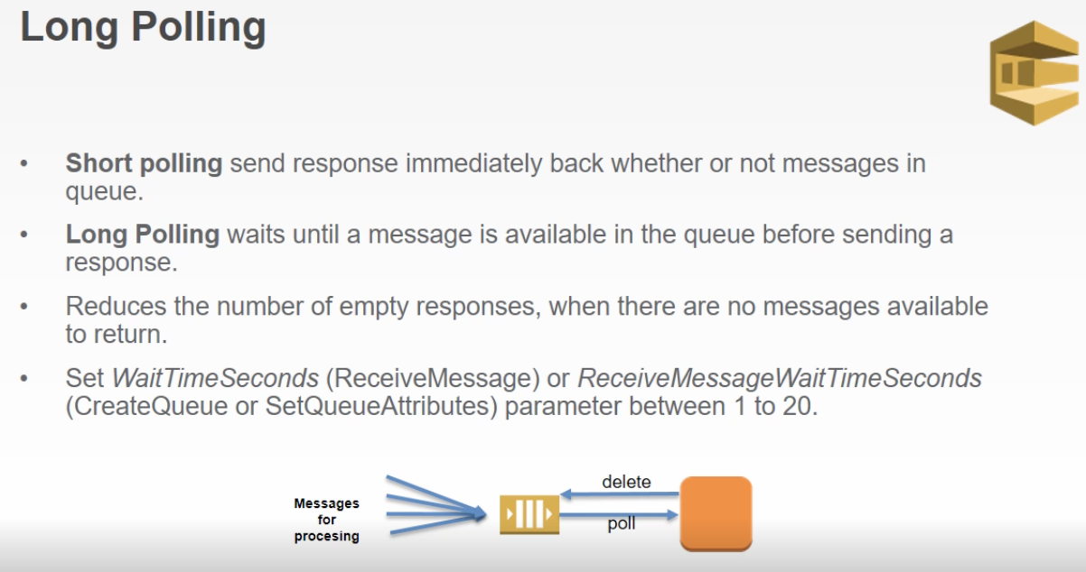

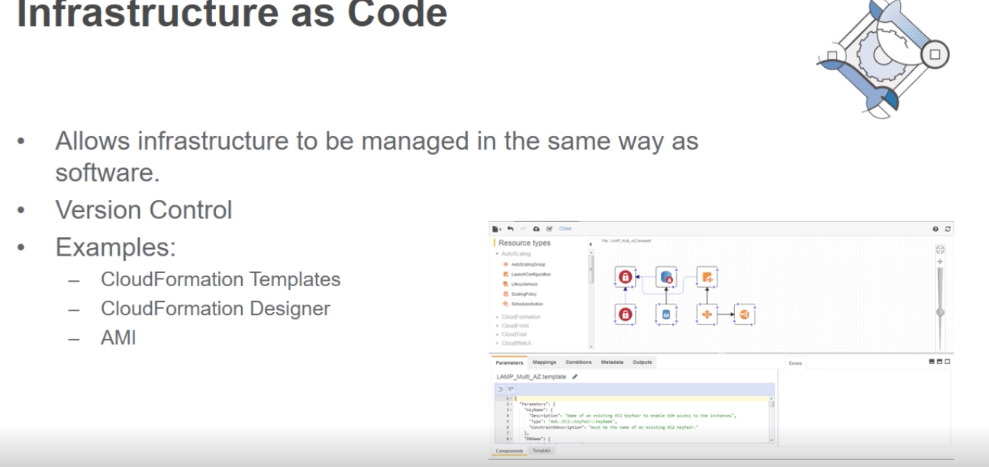

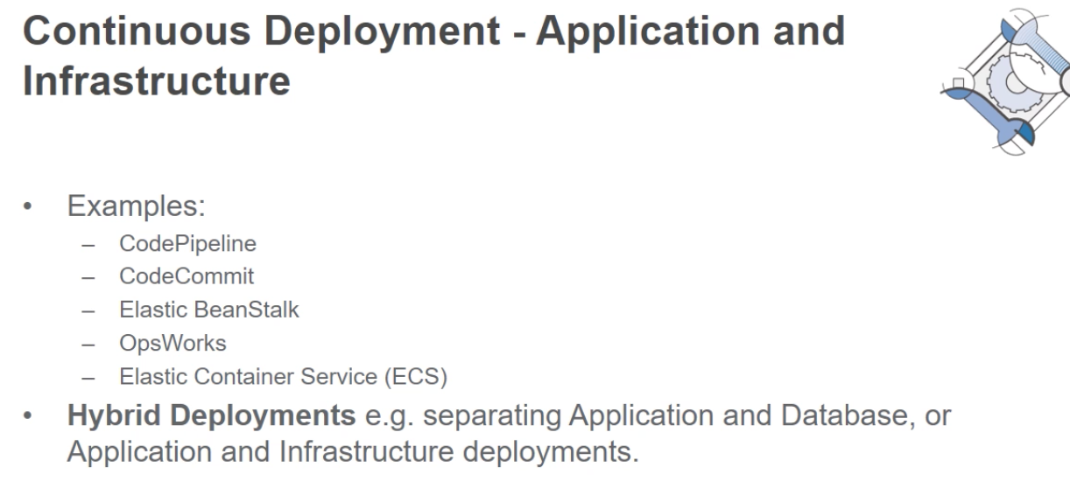

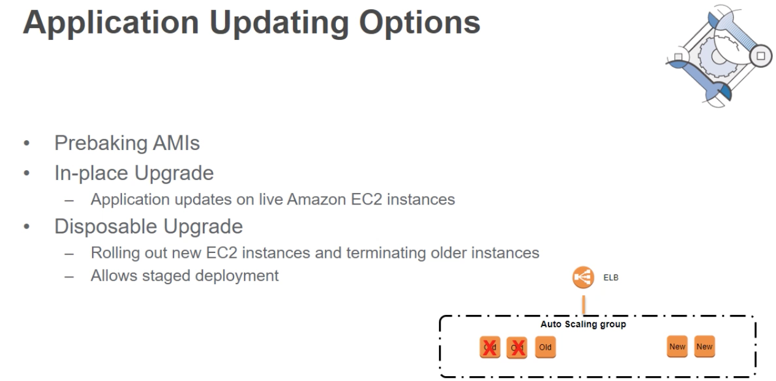

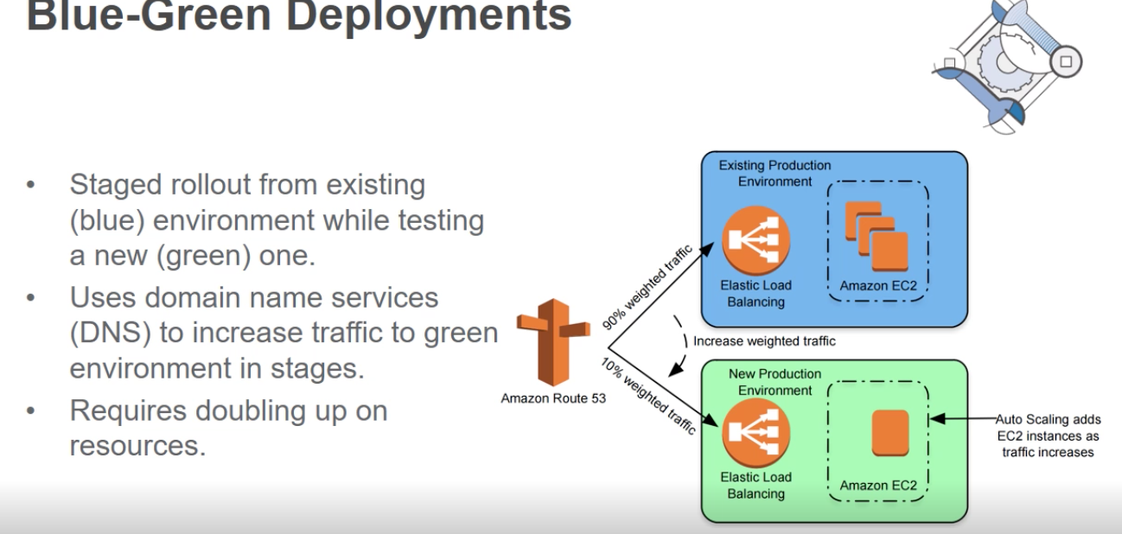

Ensures not all the users are exposed to possible bug in the new environment.

Elastic Cache – to cache a database.

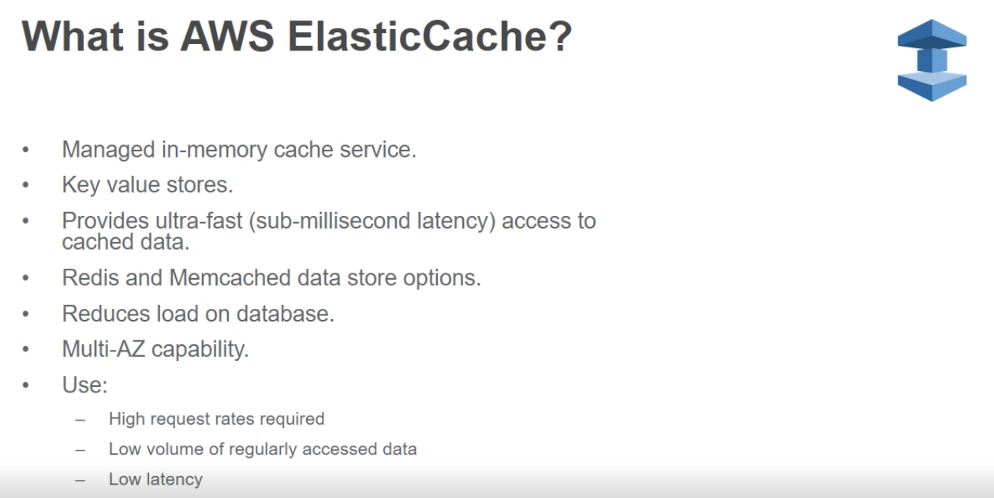

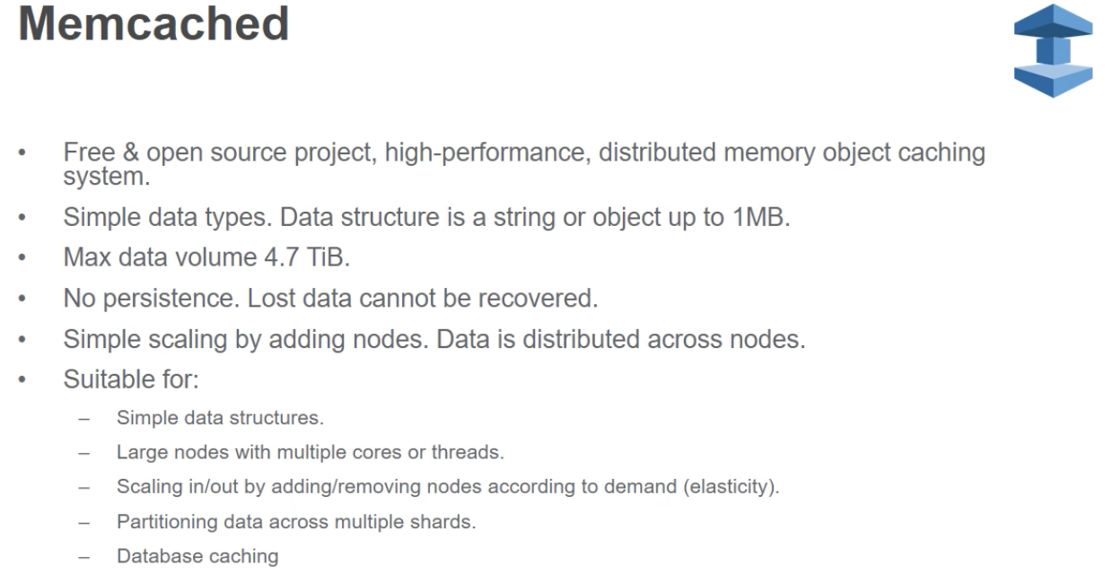

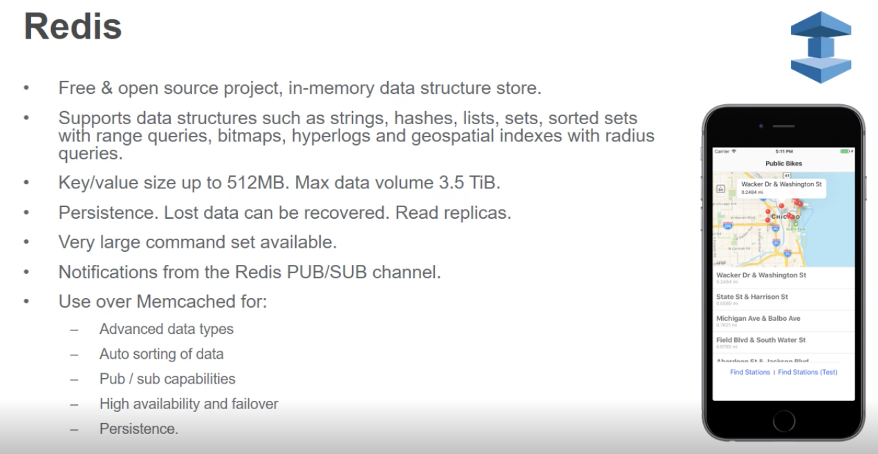

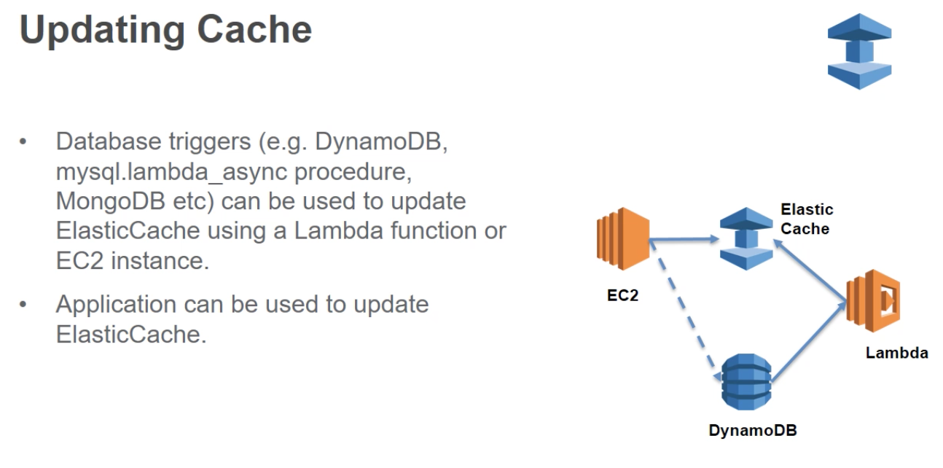

Lazy Loading – if the request comes in into El Cache and the data is not available, the replication will go to the data source, retrieve that data, put it into Elastic Cache and return it to the requester.

Write Through

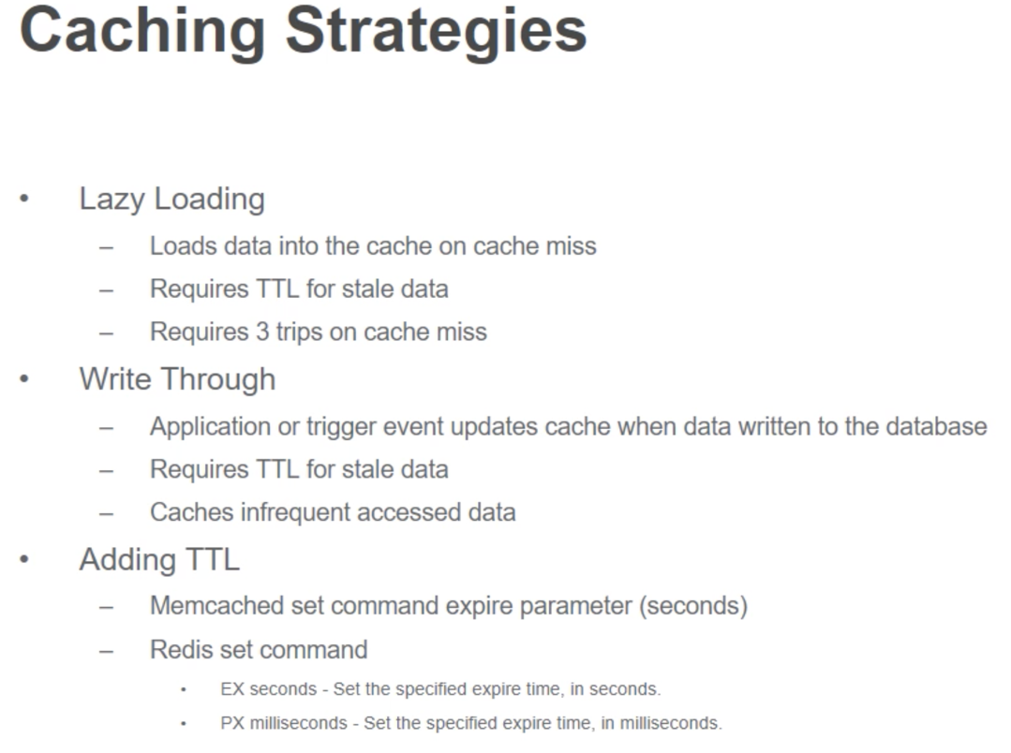

Deployment

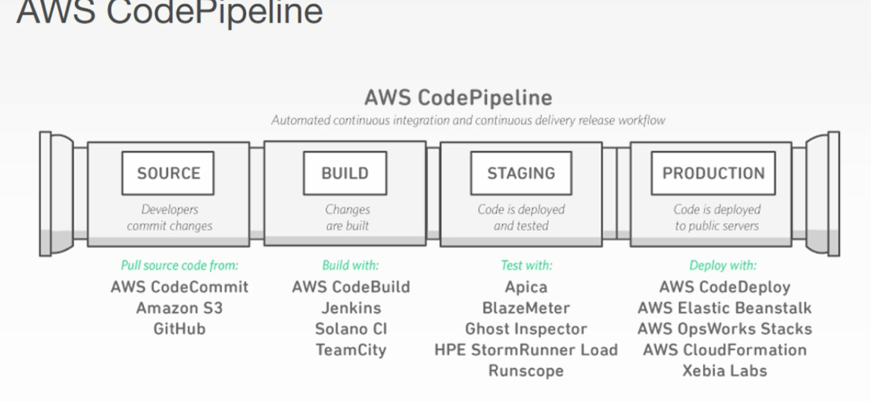

The pipeline will pull the code. After it builds and doesn’t fail unit testing it can be deployed to production. You can use BeanStallk to create production environment